TAMILNADU GOVERNMENT POLYTECHNIC COLLEGE(AUTONOMOUS)

# MADURAI-11



**DEPARTMENT OF COMPUTER ENGINEERING**

**16464 - COMPUTER SERVICING AND NETWORK PRACTICAL**

**Name: Reg. No. Roll No.**

TAMIL NADU GOVERNMENT POLYTECHNIC COLLEGE,

MADURAI -11



**DEPARTMENT OF COMPUTER ENGINEERING**



BONAFIDE CERTIFICATE

**Name………………………………………………………………………. Reg.No……………………………**

**Roll No…………………………………………………………………….. Semester…………………………..**

**Certified that this is a bonafide record of work done**

**by………………………………………………………………………………………………………………………………in the**

**………………………………………………………………………………………………………………………. During the year 20 - 20**

RECORD MARKS

Signature of Lab in-Charge Head of the Department

Submitted for the practical Examination held on…………………………………………………………..

Internal Examiner External Examiner

**CONTENTS**

|  |  |  |  |  |
| --- | --- | --- | --- | --- |
| **SLNO** | **DATE** | **NAME OF THE EXPERIMENT** | **MARKS** | **SIGNATURE OF THE STAFF** |
| **I** |  | **IDENTIFICATION OF SYSTEM LAYOUT** |  |  |
| **1.** |  | **HARD DISK** |  |  |
| **2.** |  | **DVD AND BLU RAY DISC** |  |  |
| **3.** |  | **PRINTER INSTALLATION SERVICE** |  |  |
| **4.** |  | **ASSEMBLE ADD-ON CARD & INSTALL DUAL OS** |  |  |
| **II** |  | **IDENTIFICATION OF MOBILE PHONE COMPONENTS** |  |  |
| **5(A)** |  | **ASSEMBLINGAND DISASSEMBLING OF MOBILE PHONE** |  |  |
| **5(B)** |  | **TROUBLESHOOTING OF MOBILE PHONE** |  |  |
| **6** |  | **FLASHING, FORMATTING AND UNLOCKING MOBILE PHONE** |  |  |
| **7** |  | **CABLING WORK IN A NETWORK** |  |  |
| **8(A)** |  | **CONFIGURE HOST IP,SUBNET MASK AND DEFAULT GATEWAY IN A SYSTEM** |  |  |
| **8(B)** |  | **CONFIGURE INTERNET CONNECTION AND USE IPCONFIG,PING,TRACERT AND NETSAT UTILITIES TO DEBUG THE NETWORK ISSUES.** |  |  |
| **9(A)** |  | **INSTALL NETWORK DEVICES** |  |  |
| **9(B)** |  | **WIRED AND WIRELESS NIC** |  |  |
| **10** |  | **FTP AND NETWORK PRINTERS** |  |  |

|  |  |  |  |  |
| --- | --- | --- | --- | --- |
| **SLNO** | **DATE** | **NAME OF THE EXPERIMENT** | **MARKS** | **SIGNATURE OF THE STAFF** |
|  |  | **SYSTEM ADMINISTRATION LAB** |  |  |
| **1** |  | **WINDOWS SERVER 2008 INSTALLATION** |  |  |
| **2** |  | **INSTALL HARDWARE DEVICES AND DRIVERS** |  |  |
| **3** |  | **ACTIVE DIRECTORY SERVICES** |  |  |
| **4** |  | **DHCP SEVER INSTALLATION AND CONFIGURING** |  |  |
| **5(A)** |  | **MAIL SERVER INSTALLATION AND CONFIGURATION** |  |  |
| **5(B)** |  | **INSTALL REDHAT LINUX IN GRAPHICAL MODE** |  |  |
| **6(A)** |  | **INSTALL REDHAT LINUX IN VMWARE** |  |  |
| **6(B)** |  | **CREATING USER IN LINUX SERVER** |  |  |
| **7(A)** |  | **CONFIGURING AND TROUBLESHOOTING INITAB** |  |  |
| **7(B)** |  | **CONFIGURING AND TROUBLESHOOT ETC/GRUB** |  |  |
| **8** |  | **CONFIGURING AND TROUBLESHOOT OF ETC/PWD** |  |  |
| **9** |  | **TCP/IP NETWORK CONFIGURATION** |  |  |
| **10** |  | **SHARING OF DATA USING SAMBA SERVER** |  |  |

Computer Servicing

And Networking LAB

# PART-A

# 1.Front panel indicators & switches and Front side & rear side Connectors.

**Aim:**

To identify the front panel indicators and switches and rear side connector in a computer system.

**Procedure:**

**Tower Case:**

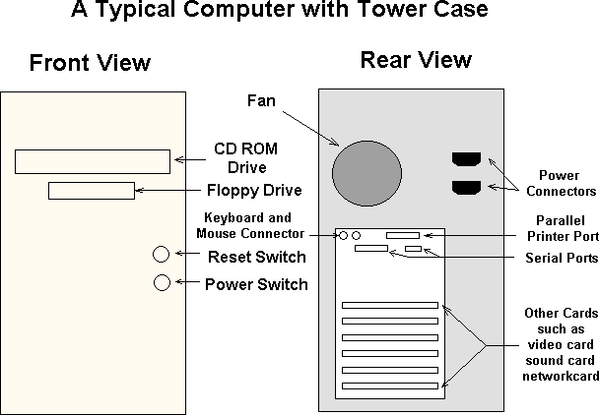

**Hard Drive Activity LED:**

LED provides visual indication that data is being read from or written to the hard drive.

# Reset Switch:

Supporting the reset function requires, a momentary-contact switch that is normally open. When the switch is closed, the board resets and runs POST.

# Power Switch:

Supporting the power on/off function requires, a momentary-contact switch that is normally open. The switch should maintain contact for at least 50 ms to signal the power supply to switch on or off.

# Drive bays:

Drive bays are most commonly used to store disk drives, although they can also be used for front-end USB ports, I/O bays, card readers, fans, tool storage, and otheruses.

* **5.25" -** Full-height bays were found in old PCs in the early to mid-1980s. They were approximately 3.5" high by 5.75" wide, and used mainly for hard disks and floppy disk drives. Half-height drive bays are approximately 1.75" high by 5.75" wide, and are the standard housing for CD and DVD drives in moderncomputers.
* **3.5" -** 3.5" bays, their actual dimensions are 4" wide by 1" high. Those with an opening in the front of the case are generally used for floppy or Zipdrives

# http://support.gateway.com/s/manlib/desktops/8506114/images/06114c1a.jpghttp://t3.gstatic.com/images?q=tbn:ANd9GcRjO4Ek8q_tKHu705DymTG9wAvybj8WB-H2gJPTm5regeICdkQqngFront Side Connectors:

**USB Connectors:**

* USB (Universal Serial Bus) is a way of setting up communication between a computer and peripheral devices. USB is intended to replace many varieties of serial and parallel ports. USB can connect computer peripherals such as mice, keyboards, PDAs, gamepads and joysticks, scanners, digital cameras, printers, personal media players, flash drives, and external harddrives.

# Card Reader:

* Card reader" is used to reads flash memory cards. It can be a standalone device that connects to a computer via USB or it may be integrated into a computer, printer, or multifunctiondevice
* Most card readers accept multiple memory card formats, including compact flash (CF), secure digital (SD), and Sony's MemoryStick.

# Audio Jack:

* A socket for plugging in an audio source, Audio jacks are found on many types of audio equipment and musical instruments that accept external soundsources.

# Rear Side Connectors:

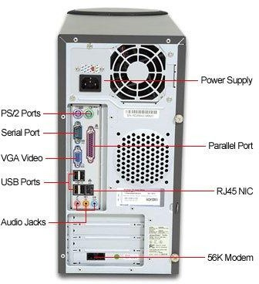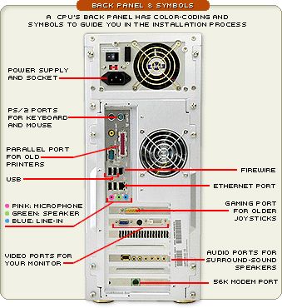

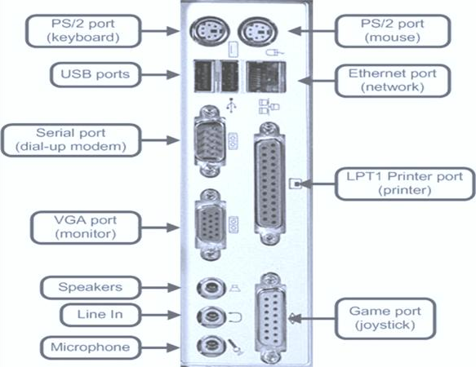

**PS/2 Port:**

* The PS/2 standard, introduced by IBM in 1987, stands for *Personal System/2*. A PS/2 port is an electronic receptacle or plug found on computers. It accepts a PS/2 cable with a mini-DIN connector, and is most often used to plug in a keyboard or mouse.
* The connector is small with a diameter of about 1/3 inch (9.5mm). It features a metal sleeve that is notched to ensure proper alignment when inserting it into the PS/2 port. This protects the circular pins inside the DIN connector from becoming bent.

# Parallel Port:

* This interface is found on the back of older PCs and is used for connecting external devices such as printers or a scanner. It uses a 25-pin connector (DB-25). The latest parallel port standard, which supports the same connectors, is called the Enhanced Parallel Port (EPP).

# Serial Port:

* The serial port is used for peripherals such as mice, gaming controllers, modems, and older printers. It is sometimes called a COM port or an RS-232port.

**Result:**

Thus the front panel indicators and switches and rear side connectors in a pc are identified.

# Familiarize the computer system Layout: Marking positions of SMPS, Motherboard, FDD, HDD, CD, DVD and add on cards.

**Aim:**

To familiarize a computer system layout and mark the positions of SMPS, Motherboard, FDD, HDD, CD / DVD drive and add on cards.

**Procedure:**

**Motherboard:**

The motherboard has been an integral part of most personal computers. The motherboard is a common circuit board. Each circuit card performs a unique function in the computer and gets its power from thesocket.

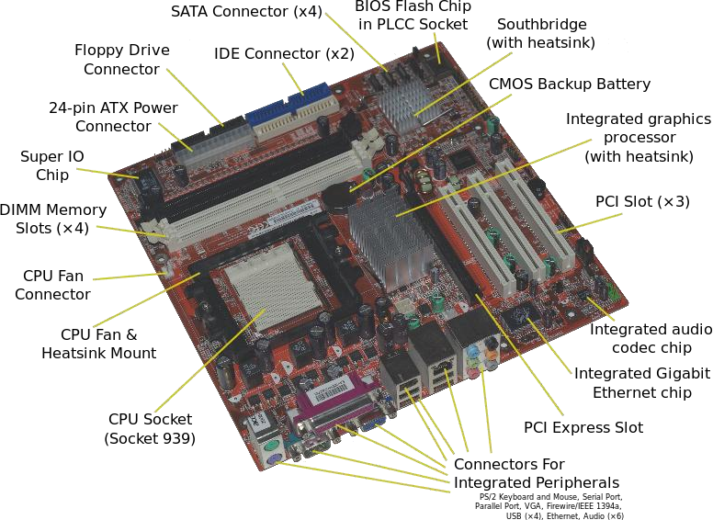

# CPU:

The CPU, or processor, is the heart of your computer no matter what type

(PC, Server, and Laptop). There are many brands for processors such as Intel and Athlon all with different processors for your computer.

8

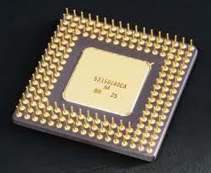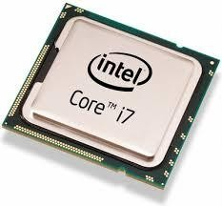

# RAM:

Random Access Memory (RAM) is the form of memory contained in most

computers. When an application is running it stores its information in the RAM. When you close the application the information is deleted from the RAM.

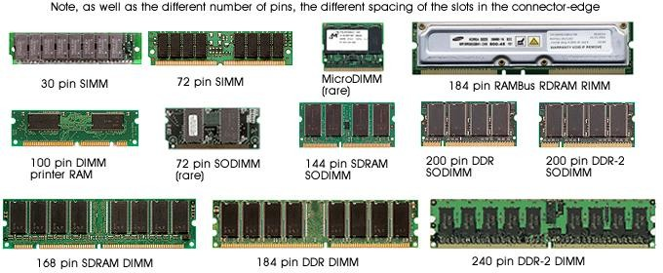

# Hard-Disk Drive:

A hard drive stores all your files and information in a permanent form unlike storing it in RAM (which is temporary). The larger your hard disk (drive) the more information and files you're able to store.

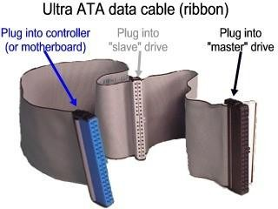`

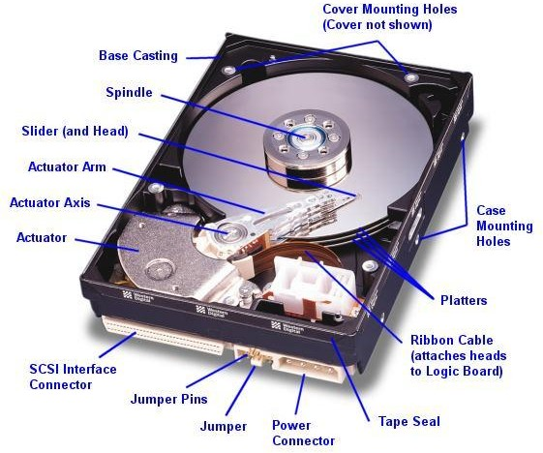

9

# CD-Rom:

The CD-Rom is reads CD's. CD-Rom completely stands for Compact Disk

Read Only Memory. CD's have much more data than a floppy disk. Using CD-RW you can make your own CD's and use them more like a floppydisk.

# http://helpingindia.com/images/cdrom_cd5225_bk.jpghttp://t2.gstatic.com/images?q=tbn:ANd9GcQ3veinG58Ju3LrYTmUBgZdx2NcDQWf1uYP9uHJKDKC2eI3pVy_CD-Rom: CD-disk

**IDEcable: SATAcable**

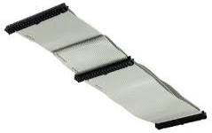 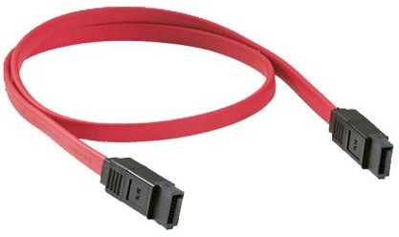

# DVD-Rom:

DVD-ROM is a [digital](http://en.wikipedia.org/wiki/Digital_media) [optical disc](http://en.wikipedia.org/wiki/Optical_disc) [storage](http://en.wikipedia.org/wiki/Data_storage_device) format. DVDs offer higher storage capacity than [compact discs](http://en.wikipedia.org/wiki/Compact_disc) while having the same dimensions. Blank recordable DVD discs ([DVD-R](http://en.wikipedia.org/wiki/DVD-R) and [DVD+R](http://en.wikipedia.org/wiki/DVD%2BR)) can be recorded once, Rewritable DVDs ([DVD-RW](http://en.wikipedia.org/wiki/DVD-RW), [DVD+RW](http://en.wikipedia.org/wiki/DVD%2BRW), and [DVD-RAM](http://en.wikipedia.org/wiki/DVD-RAM)) can be recorded and erased multiple times.

# Floppy Drive:

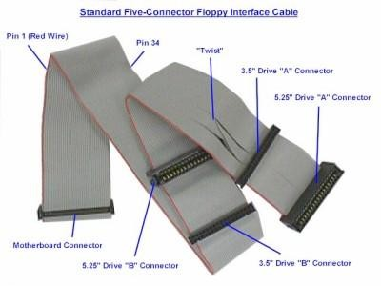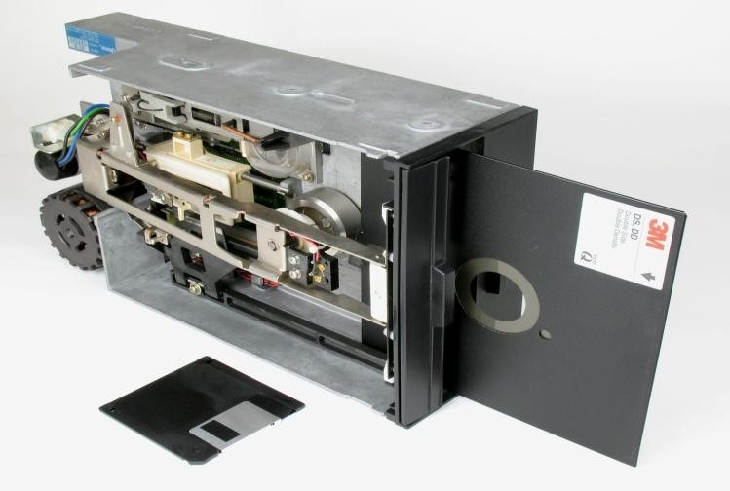A floppy drive reads the popular floppy disk. Floppy disk is easy to use, rewritable, compact, and great for storing information. The floppy drive is simple and allows you to read, write to, and write over information stored on a floppy disk.

# Power Supply:

The power supply is usually a small metal box in the top corner of a case (tower). You can see the power supply as below diagrams.

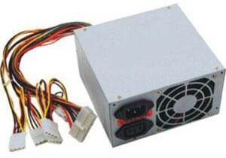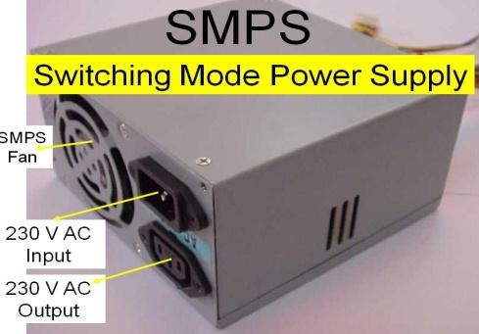

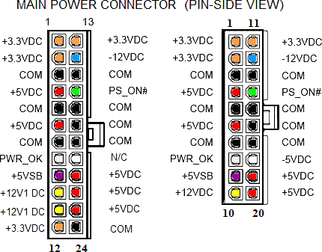

# Access Slots:

Access slots or expansion slots are openings in a computer where a circuit board can be inserted to add new capabilities to the computer. Examples of drives that may go here would be modems; USB drives, networking cards, video adapters, and soundcards.

# http://thevaluestore.in/supershop/image/cache/data/enter/Enter-E-1P-Pci-1-Port-Parallel-Add-On-Card-500x500.jpgIO card:

**Result:**

Thus the computer system layout in SMPS, Motherboard, FDD, HDD, CD, DVD and add on cards of the pc’s are identified.

# Configure BIOS setup program and troubleshoot the typical problems using BIOS utility.

**Aim:**

To configure BIOS setup program and troubleshoot the typical problems using BIOSutility**.**

**Procedure:**

**Bios Setup:**

The BIOS Setup utility reports system information and can be used to configure the server BIOS settings.

BIOS have a Setup utility stored in the BIOS flash memory. The configured data is stored in the system's battery-backed CMOS RAM.

To access BIOS configuration screens and to change the system’s parameters complete the following steps:

* + Power on or power cycle theserver.
  + To enter the BIOS Setup utility, press the F2 key while the system is performing the power-on self-test(POST)
  + 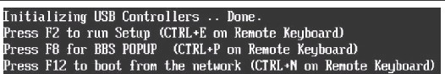Press F2 to Run SetupPrompt
* When BIOS is started, the main BIOS Setup utility top-level screen appears. This screen provides seven menu options across the top of thescreen.
* Use the left and right arrow keys to select the different menuoptions
* To select an option on a top-level screen, use the up and down arrow keys to scroll up and down the optionspresented.

Only options that can be modified are highlighted when you press the up and down arrow keys.

* If a field can be modified, as you select the option, user instructions for modifying the option appear in the right column of thescreen.
* If a field is a link to a sub-screen, instructions to press the **Enter** key to access the sub screen appear in the rightcolumn.
* Modify the setup field and press the Esc key to save the changes and exit the screen. Some screens present a confirmation dialog box that enables unwanted changes to beretracted.
* On sub-screens that only provide configuration information and cannot be modified, press the Esc key to exit thescreen.
* Tocontinuemodifyingothersetupparameters,repeat[Step3](http://docs.oracle.com/cd/E19269-01/820-5830-13/app_bios.html#50634772_30220)through[Step](http://docs.oracle.com/cd/E19269-01/820-5830-13/app_bios.html#50634772_31914)

[6](http://docs.oracle.com/cd/E19269-01/820-5830-13/app_bios.html#50634772_31914). Otherwise, go to [Step 8](http://docs.oracle.com/cd/E19269-01/820-5830-13/app_bios.html#50634772_36618)

* Press and release the right arrow key until the Exit menu screenappears.
* Follow the instructions on the Exit menu screen to save or discard your changes and exit the BIOS Setuputility.

# BIOS Setup Screens Overview:

|  |  |
| --- | --- |
| **Screen** | **Description** |
| Main | General product information, including BIOS type, processor, memory, and time/date. |
| Advanced | Configuration information for the CPU, memory, IDE, Super IO, trusted computing, USB, PCI, MPS and other information. |
| PCI | Configure the server to clear NVRAM during system boot. |
| Boot | Configure the boot device priority (storage drives and the DVD-ROM drive). |
| Security | Set or change the user and supervisor passwords. |
| Chipset | View the configuration of server chipsets. |
| Exit | Save changes and exit, discard changes and exit, discard changes, or load optimal or fail-safe defaults. |

**BIOS Setup Utility Menu Screens :**

The BIOS Main screens provide general product information, including BIOS, processor, system memory, and system time/date.

# BIOS Setup Utility: Main

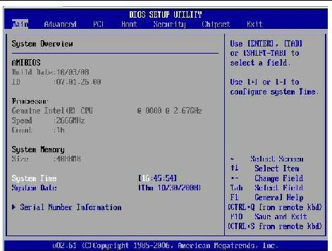

**Advanced Setting:**

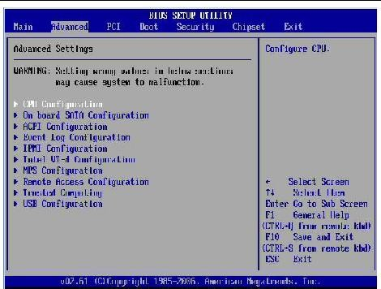

**Exit - Save Configuration Changes and Exit Confirmation:**

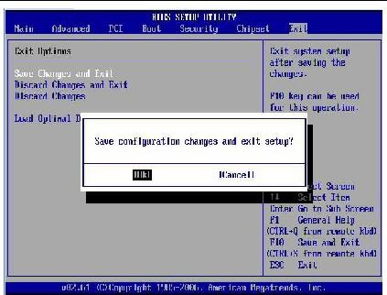

**BIOS Power-On Self-Test (POST) Events:**

At system startup, the BIOS perform a power-on self-test that checks the hardware on your server to ensure that all components are present and functioning properly.

**Result:**

Thus the bios setup program and troubleshoot the typical problems using BIOS utility of the pc’s are identified.

# Ex.No:1. To install Hard Disk and configure to the Pc’s Aim: To HDD disk

(A) Install Hard Disk. (B)Configure CMOS-Setup. (C)Partition and Format Hard Disk.

1. Identify Master /Slave / IDE Devices.
2. Practice with scan disk, disk cleanup, disk De-fragment, Virus Detecting and Rectifying Software.

# 1(A).Install Hard Disk:

**Procedure:**

[**How to Install a Hard Drive**](http://www.wikihow.com/Install-a-Hard-Drive)**:**

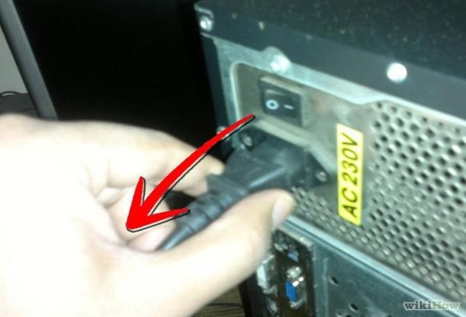**Steps:**

* **Unplug your computer and switch off the power supply.**
* **Locate the hard drive bay on the front of the computer.** Put the hard drive in the hard drive bay and line up the screw. Secure the hard drive into the hard drive bay with screws.

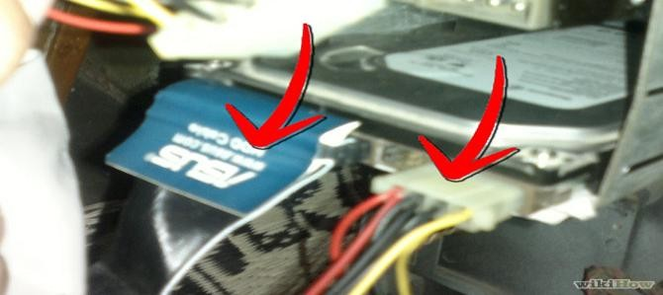

* **Find the cables that came with your hard drive.** Match the connectors on the back of the hard drive to the cables and attach them. Find the corresponding connectors on the motherboard and plug themin.
* **Set the drive jumper to the master setting if you are installing an IDE drive.** Look on the hard drive or in the manual that came with your harddrive

for the jumper settings. Use a pair of needle nose pliers to adjust the jumper to the proper setting.

* **Put the side panel back on the computer and secure it with the screws.** Plug the computer back in and flip the power supply switch back to "On."

# 1(B).Configure CMOS-Setup: Procedure:

* Go into your BIOS. Press F10 or DEL atstartup.
* Advancedsettings

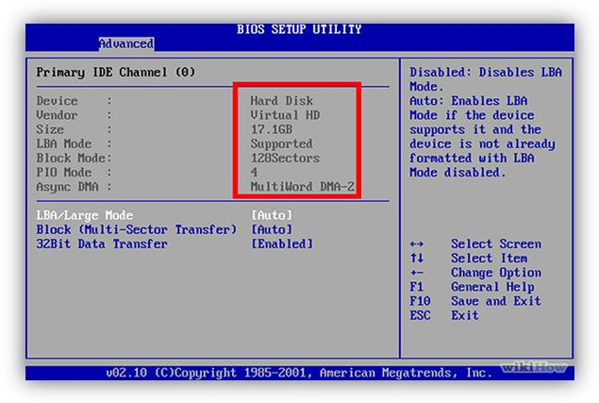Go to "auto detects hard drives."

* Ensure that it detects your new harddrive.

If it doesn't detect the drive, go back and make sure the cables are inserted tightly.

# 1(C).Partition and Format Hard Disk:

**Create and format a hard disk partition:**

You must be logged on as an administrator to perform these steps.

To create a partition or on a hard disk, there must be either unallocated (empty) space on the hard disk or free space within an extended partition on the hard disk.

If there is no unallocated space, you can create some by shrinking an existing partition, deleting a partition, or by using a third-party partitioning program.

# [To create and format a partition (volume)](http://windows.microsoft.com/en-in/windows/create-format-hard-disk-partition):

Open Computer Management by clicking the Start button, clicking Control Panel, clicking System and Maintenance, clicking Administrative Tools, and then double-clicking Computer Management.

1. In the Navigation pane, under Storage, click DiskManagement.
2. Right-click an unallocated region on your hard disk, and then click New SimpleVolume.
3. In the New Simple Volume Wizard, clickNext.
4. Type the size of the volume you want to create in megabytes (MB) or accept the maximum default size, and then clickNext.
5. Accept the default drive letter or choose a different drive letter to identify the partition, and then clickNext.
6. In the Format Partition dialog box, do one of thefollowing:
   * If you don't want to format the volume right now, click do not format this volume, and then clickNext.
   * To format the volume with the default settings, clickNext.
7. Review your choices, and then clickFinish.

# [To format an existing partition (volume)](http://windows.microsoft.com/en-in/windows/create-format-hard-disk-partition):

* + Formatting a volume will destroy any data on the partition. Be sure to make backups of any data you want to save before youbegin.
  + You cannot format a disk or partition that is currently in use, including the partition that containsWindows.
  + Quick format is a formatting option that creates a new file table but does not fully overwrite or erase thevolume.

1. Open Computer Management by clicking the Start button , clicking Control Panel, clicking System and Maintenance, clicking Administrative Tools, and then double-clicking Computer Management. If you are prompted for an administrator password or confirmation, type the password or provide confirmation.
2. In the Navigation pane, under Storage, click DiskManagement.
3. Right-click the volume that you want to format, and then clickFormat.
4. To format the volume with the default settings, in the Format dialog box, click OK, and then click OKagain.

# 1(D).Identify Master /Slave / IDE Devices:

**How to Set Jumpers for Your Computer’s IDE Drive:**

SATA drives each have their own [cable](http://www.dummies.com/how-to/content/how-to-set-jumpers-for-your-computers-ide-drive.html#glossary-cable) that connects to the computer’s [motherboard](http://www.dummies.com/how-to/content/how-to-set-jumpers-for-your-computers-ide-drive.html#glossary-motherboard). IDE drives share a single cable. When two drives share one cable, you give them different names. IDE drives, those names are “Master” and“Slave.”

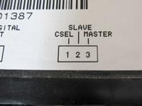 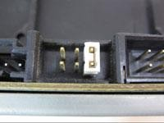

1. Find the drive’s Master/Slave identification chart usually printed in black on a sticker attached to yourdrive.
2. If your drive doesn’t have a sticker, visit the drive manufacturer’s Web site and downloads the pinsettings.
3. Locate the drive’s Master/Slavepins.

These both live near where the data and power cables plug into the drive. You’ll find six or more pins, but they’re always set in pairs like the ones in the photo.

1. With a pair of tweezers or needle-nose pliers, place the jumper (a little plastic thingy) across the correct pair of pins, either Master orSlave.

**Result:**

Thus the Install Hard Disk, configure CMOS-Setup, partition and format

Hard Disk and Identify Master /Slave / IDE Devices of the successfully installed.

# 1(E).Practice with scan disk, disk cleanup, disk De-fragment, Virus Detecting and Rectifying Software.

**Procedure:**

**Using Scandisk and Disk Defragmenter:**

Scandisk and Disk Defragmenter (Defrag) are two programs that when run in conjunction with each other have the ability to detect and resolve many of the problems which can cause poor performance and in more serious cases the loss of files.

# Running Scandisk:

* + ClickonStartClickon**AllPrograms**>**Accessories**>**SystemTools**>

**Scandisk** respectively.

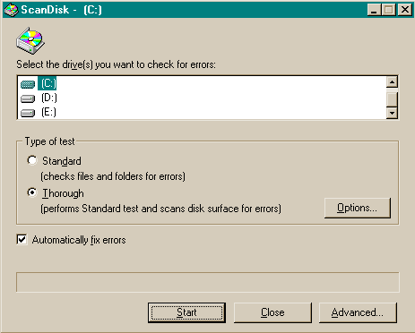You should see the following window:

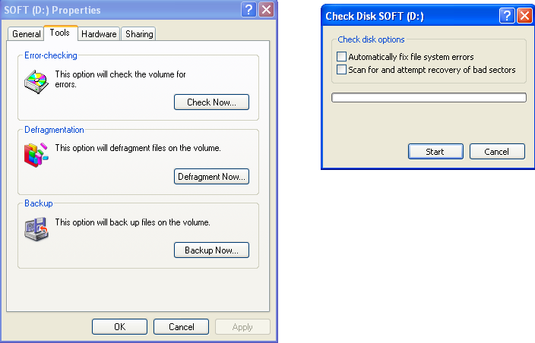

* + If you run Scandisk monthly you need only check the "Thorough" box the first time you run theprogram.
  + Always be sure to check the "Automatically fix errors" radiobutton

# Running Defragment:

* + Click on **All Programs** >**Accessories** >**System Tools** >**Defragment**. You should see the followingwindow:

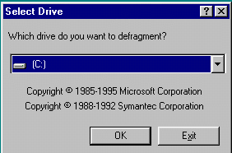

* + Click OK and you will see a window that looks something likethis:

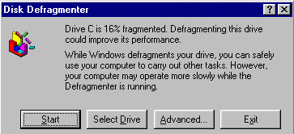

* + Choose Start to run theprogram.

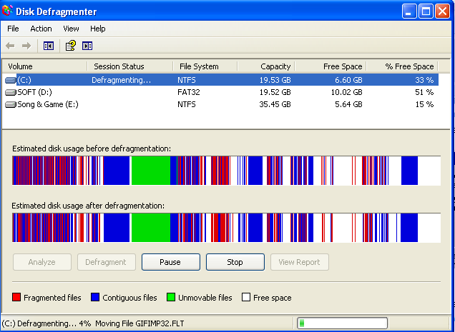

# Running Disk Cleanup: Procedure:

1. ClickStart.
2. Click **All Programs** >**Accessories** >**System Tools** >**Disk Cleanup**. You should see the Disk Cleanup: Drive Selection dialog box that looks similarto thefollowing:

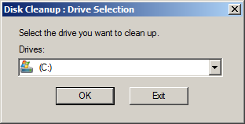

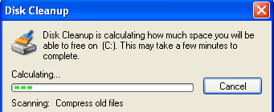

1. From the pull-down menu, choose the drive you want toclean.
2. ClickOK.
3. Disk Cleanup will calculate the free space on your computer, which may take a fewminutes.
4. After the calculation is complete, you should see a dialog box that looks similar to thefollowing:

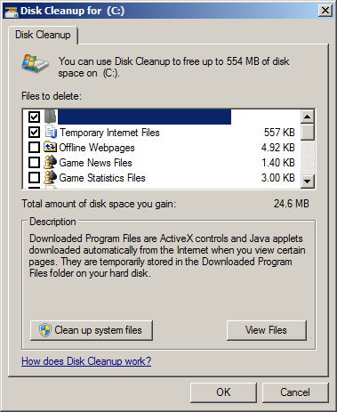

1. Confirm that only the following check boxes arechecked:

# Downloaded ProgramFiles

* + **Temporary InternetFiles**
  + **RecycleBin**
  + **TemporaryFiles**

1. ClickOK.
2. You should see a dialog box that asks Are you sure you want topermanently delete thesefiles?

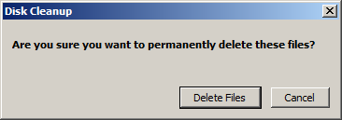

1. Click DeleteFiles.
2. Disk Cleanup will delete the files and closeautomatically.

# Virus Detecting and Rectifying Software:

1. ClickStart.

# Click All Programs >avastantivirus>Scan.

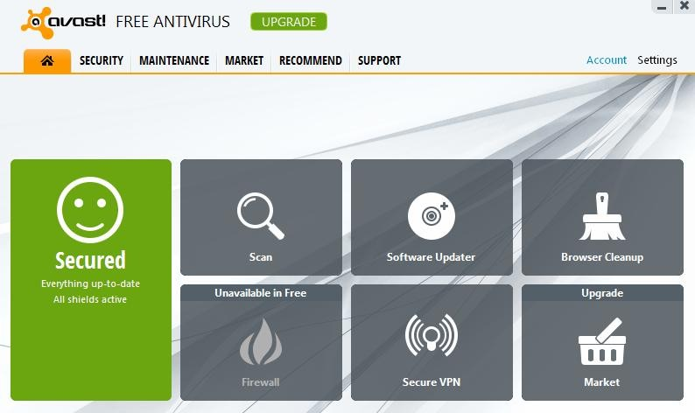

1. Click **All Programs** >**avastantivirus**>**Scan.**

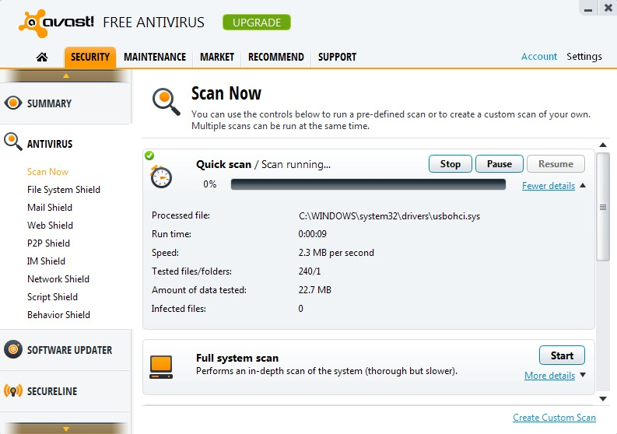

**Result:**

Thus the scan disks, disk cleanup, disk De-fragment, Virus Detecting and Rectifying Software to the pc’s are installed successfully.

# Ex.No:2.Install and Configure a DVD Writer and a Blu-ray Disc writer and

**recording DVD and Blu-ray disk.**

**Aim:**

To Install and Configure a DVD Writer and a Blu-ray Disc writer and

recording a Blank DVD and Blu-ray Disc blank in a computer system**. Procedure:**

# To install an external DVD & Blu-ray drive:

* + **When purchasing a new drive be sure to:** DVD+/-RW and Blu-Ray Disc
  + **If you have a USB connection on your computer you can use an external drive.** The advantage to an exterior drive is that you can use it on other computers aswell.

# To install an internal DVD & Blu-ray drive:

* + **Look for a DVD with the letters RW on the box.** This is so you can read disks and record them as well. Make sure the speed rating is16X.
  + Disconnect the power cord from the back ofthe
  + Open the case of thecomputer.
  + **Locate the DVD drive.** Most have two connections and can only be snapped in place one way. One connection is for data and one forpower.
  + Check to see if your computer mounts the DVD/CD ROM drives from the inside or if they are pushed through the front panel (you may have to remove the plastic panel on somemodels.)

# Carefully remove the plastic“knock-off.

* + **Slide the DVD drive into an empty compartment orbay.**
* **Connect the DVD drive to the datacable.**
* **Look the DVD to the powerconnector.**
* **Re-assemble the cover and plug the computer backin.**

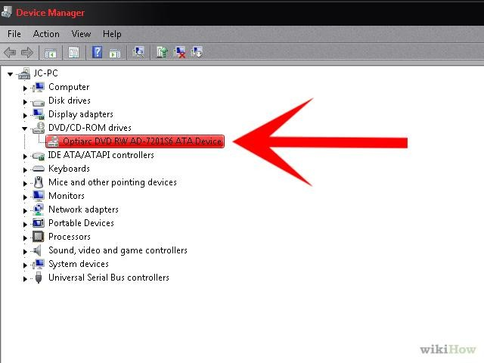

**To record a blank DVD & Blu-ray:**

* Insert the blank DVD in the DVDwriter.
* Double click the Nero icon in thedesktop.
* 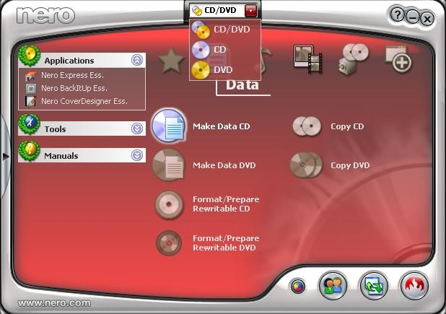Then selection the neededoptions.
  + To add the favorites file to copy in thedisk.

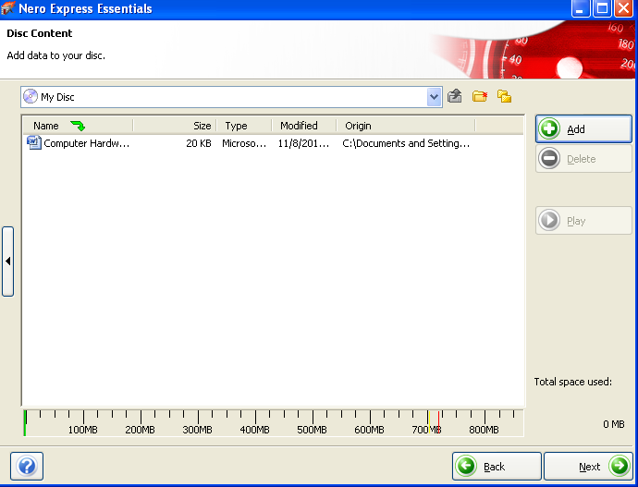

* + Click the burnbutton.

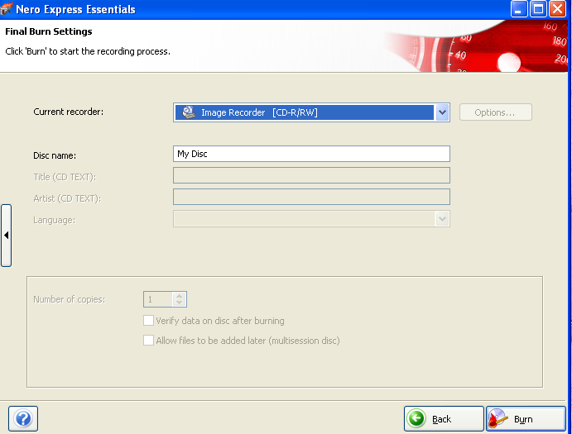

* + 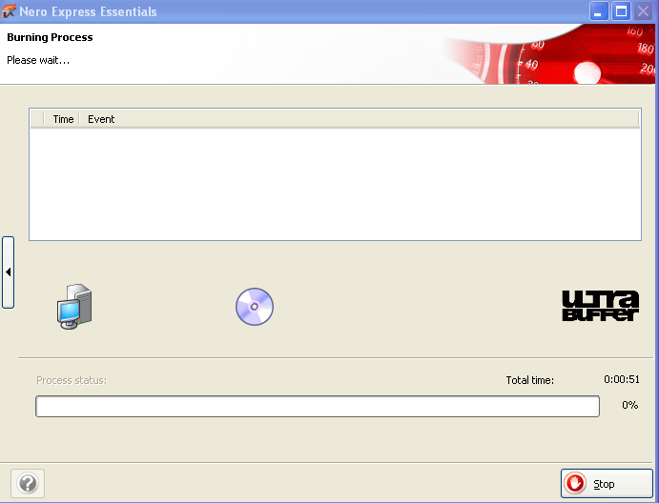Then the files are recorded into the blankdisk.
  + Then finishedrecorded.

**Result:**

Thus the Install and Configure a DVD Writer and a Blu-ray Disc writer and recording DVD and Blu-ray disk to the pc’s are installed successfully.

# Aim:

**Ex.No:3. Printer Installation and Servicing and troubleshoot**

**Printer Installation and Servicing:**

1. Head Cleaning in dot matrixprinter
2. Install and configure Dot matrix printer and Laserprinter
3. Troubleshoot the aboveprinters.
4. Check and connect the data cableconnectivity

**Procedure:**

**3(a).Head Cleaning in dot matrix printer:**

* + Adjust the print headspacing.
  + Check the tession on the print head positioning belt. use a non fibrous swap dipped in alcohol to clean theprint.
  + Clean the printer rollersurface.
  + Clean the gear train of the paper handlingmotor.
  + Apply light oil torails.
  + Move the carriage assembly to distribute the oil. **3(b).Install and configure Dot matrix printer and Laser printer: (i)To Install and configure Dot matrixprinter:**
  + Connect the printer to parallel port of the motherboard and power cable to AC.
  + Switch on the system andprinter.
  + Insert the driver disk in the CDdrive.
  + Click **start >control panel**>**printers and fax** respectively. You should see the followingwindow:
  + Then >**double click**>**add a printer**>**add printer wizard** respectively. You should see the followingwindow:

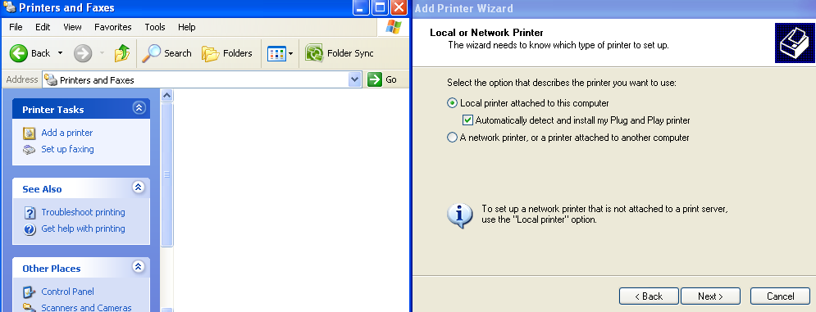

* 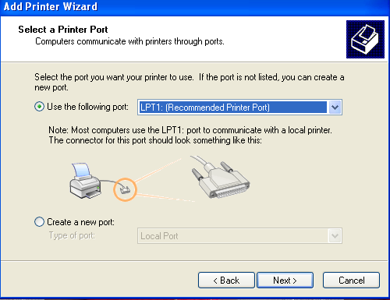click next add printer wizardappear.
* Click next until a list of model, manufacturer and clicknext.
* Select the correct printer model, manufacturer and clicknext.

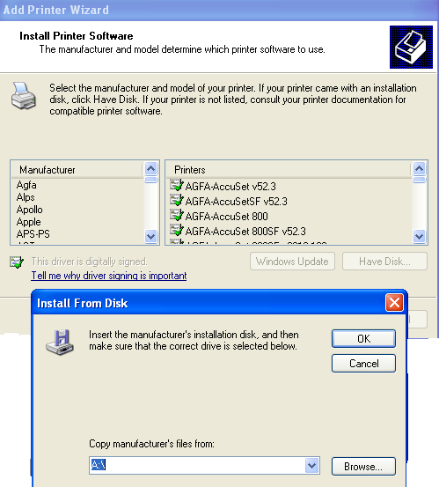

* Then, follow the instructions on the computerscreen.
* After installation restart the system and check theprinter.

# To Install and configure Laserprinter:

* + Connect the printer to parallel port or USB port the motherboard and power cable toAC.
  + Switch on the system andprinter.
  + Insert the driver disk in the CDdrive.
  + Click **start >control panel**>**printers and fax** respectively. You should see the followingwindow:
    - Then >**double click**>**add a printer**>**add printer wizard** respectively. You should see the followingwindow:





* + Click next until a list of model, manufacturer and clicknext.
  + Select the correct printer model, manufacturer and clicknext.



* + Then, follow the instructions on the computerscreen.
  + After installation restart the system and check theprinter.

# 3(c).Troubleshoot the Dot-matrix printers:

* + Printer does notfunction
  + The printer does not print during selftest.
  + Printer not ready error messagedisplayed.
  + Carriage does notmove.
  + Paper empty-notsensing.
  + No ribbonfeed.
  + Head pins problem and coilscheck.

# Troubleshoot the above Laser printers:

* + Strains of small round black appear on the front or back of thepage.
  + A blank pageprinted.

# 3(d).Check and connect the data cable connectivity:

* + See whether the cables are inserted fully into the printer port and computer port.
  + Check for any bent pins in the printer connector. If bent pins present straighten it.
  + Check the type of the cable to be used USB cables should not be longerthan 15feet.
  + Check the continuity of the cable using multimeter.

**Result:**

Thus the Install and Configure to a printer to the pc are installed successfully.

# Ex.No:4.Assemble a system with add on cards and check the working condition of the system and install OS.

**Aim:**

ToAssembleasystemwithaddoncardsandchecktheworking condition of the system and installOS.

**Procedure:**

* + - 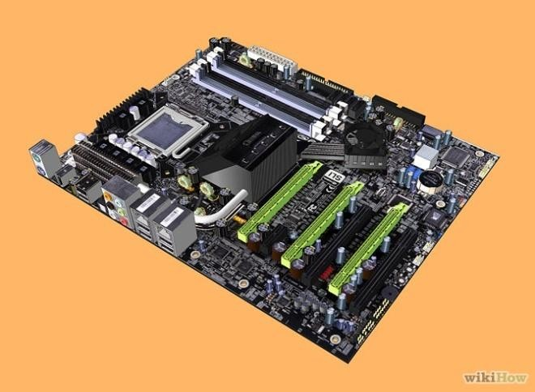Prepare the Mainboard (motherboard). If you want to assemble the well-liked device, you should use Intel G31, GMA3100, or AMD 780Mainboard.
    - 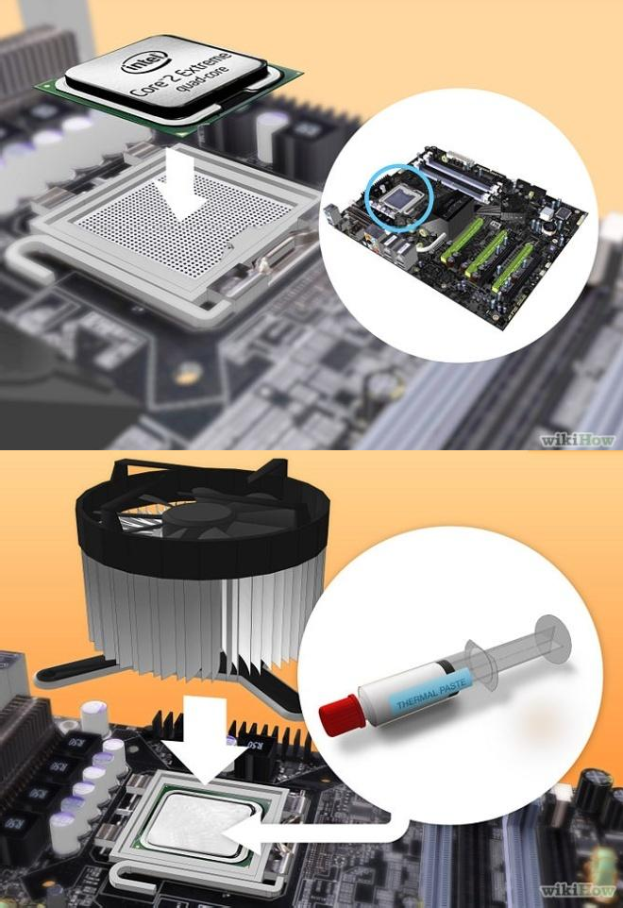Mount the CPU in the socket of the Mainboard. You must choose the correct CPU for your motherboard, and install it according to it's instructions. Be careful not to install the CPU in wrong. Not only would your computer not work, it could short-circuit and damage your motherboard.
    - Connect the CPU cooler to the Main board.
    - 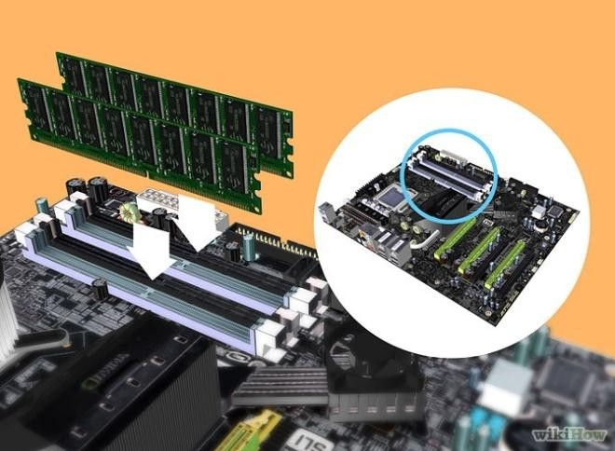Attach the RAM(memory) modules in the corresponding slots. the motherboard should have rows of slots that have 2 or 3 sections that are different lengths. Make sure the pins on the RAM cards line up with the pins on the motherboard connector. Don't get the RAMslots

mixed up with PCI slots. The PCI slots are usually wider.

* + - 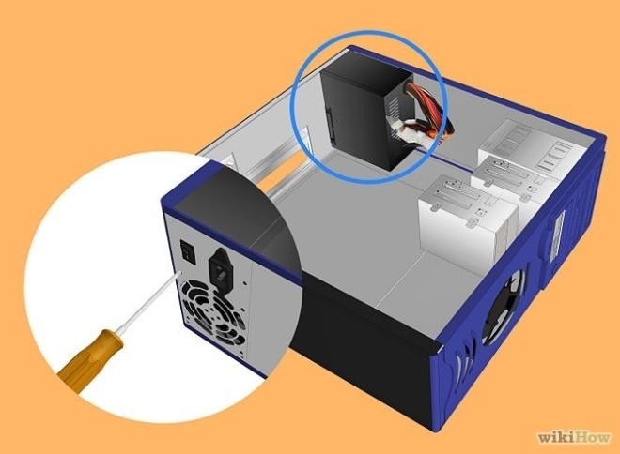Open the case and mount the power supply which is M-ATX type. Make sure to connect all the connections to the drives and themotherboard.
    - 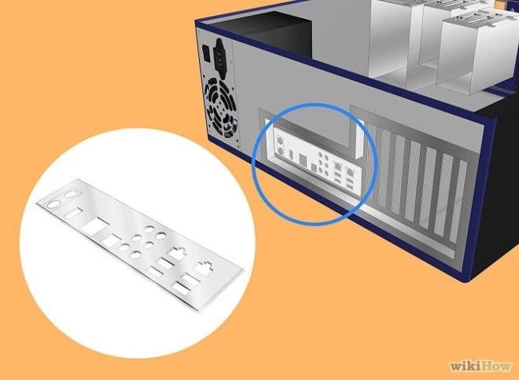Attach the Mainboard back plate to the case and check the Mainboard mounting positions. The motherboard's instructions should tell the position of themotherboard.
    - 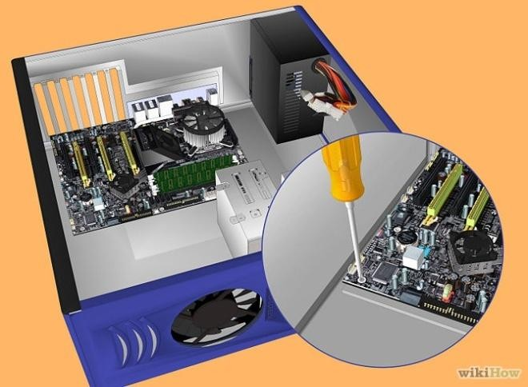Suitably position the Mainboard in the case.
    - Mount the Hard disk and connect it to the power supply and themotherboard.

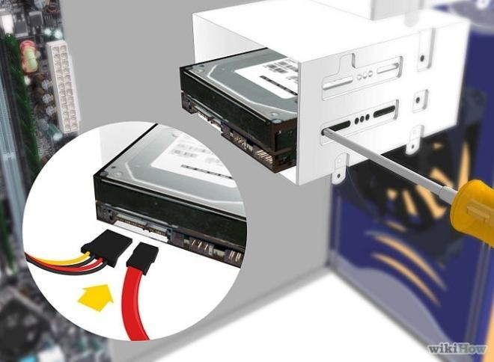There should be separate connections for the power supply and the motherboard. In SATA Hard disk case, should remove thejumper.

* + - 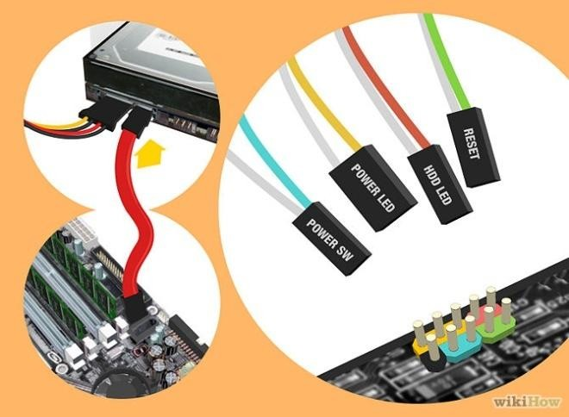Connect the SATA connectors to the drives and the USB connectors and the case switches to the motherboard. The case and motherboard's instructions should tell where to connect the cables. [[Image:Step9_790.JPG|300px|]
    - 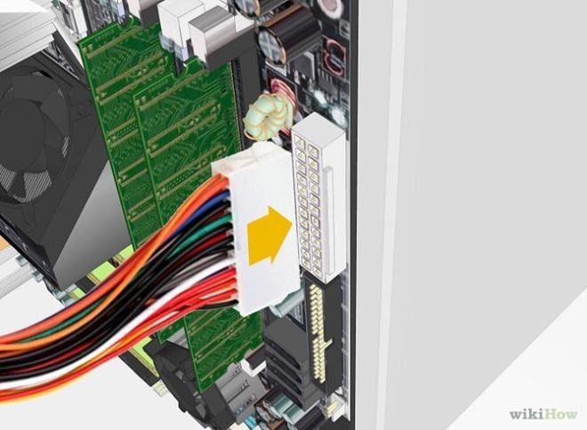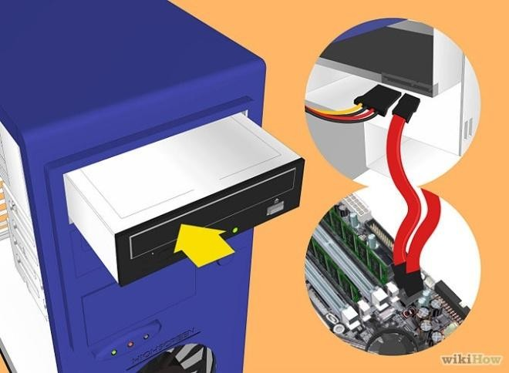Connect the 20 or 24 pin ATX connector and the 4-pin power supply control connector to the motherboard.
    - Mount the DVD-ROM drive. After connecting the ATA cable to the device, hook it up to the power supply.

# Installing a Graphics Card (Add-on):

* + - 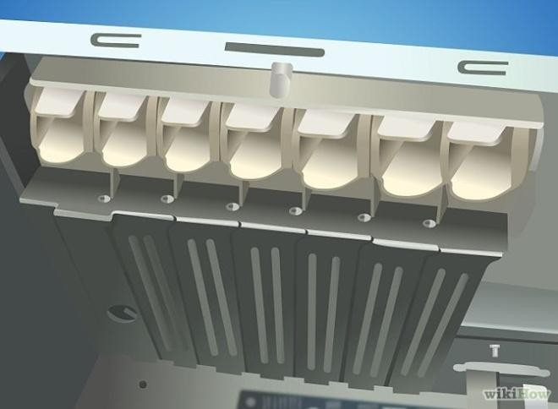Remove the back panel covers that line up with the PCI-E slot. Almost all modern graphics cards use PCI-E. Some will require you to remove two of the protective plates as opposed to just one. You may have to punch the plates out of thecase.
    - Insert the graphics card. You may have to bend a tab on the slot to allow the graphics card to be inserted. The tab will help lock the graphics card in place (this is more important for bulkier, high-end cards). Apply light, even force until the card is seated uniformly, and the back panel linesup.
    - Secure the card. Once you have inserted the card, use a screw to secure it to the back panel of the case. If you don’t secure your card, you could end up damaging it in the long run.
    - Install any other PCI cards. If you have any other PCI cards that you are add, such as a dedicated sound card, the installation process is the same as the video cardprocess.
    - Finally, Close the cabinetcase.

Select a compatible operating system and to install.

# Final Check:

Mother board jumper configurations are the settings for the processor operator.

1. Drive jumper settings, master/ slavecorrect?
2. Are the processor, RAM modules and plug in cards finally seated in there sockets?
3. Did you plug all the cables in? Do they all fitreally?
4. Have you frightened all the screws in plug- in cards or fitted theclips?
5. Are the drivesecure?
6. Have you connected the power cables to alldriver?

# Powering up for the first time:

1. Ensure that no wires are touching the CPU heat sinkfan.
2. Plug your monitor, mouse andkeyboard.
3. Plug in power card and switch the powersupply.
4. If everything is connected as it shouldbe
   * All system, fans should startspinning.
   * U should hear a single beep and after about 5-10sec.
   * Amber light on monitor should gogreen.
   * You will see computer start to boot with a memorycheck.
   * Now check front LED’S to see if u plugged them incorrectly.
   * Check all otherbuttons.
   * Power afford change any wrongsettings.

**DUAL OPERATING SYSTEM INSTALLATION.**

**Procedure:**

1. Start the computer and insert the CD in the drive .press f9 key to change first boot order as CD. Save and exit from bios setup.
2. When “press any key to boot from CD” appears, press “enter” key.
3. Click on install button.
4. Windows starts to install automatically. Choose installation type (custom)
5. Then select partition or a another harddrive and format the harddisk to install windows 8.
6. Click next. After few seconds, System will reboot. It shows two OS.
7. Choose your OS and set date time , password and user account.
8. Eject the CD from the drive.

**DUAL OPERATING SYSTEM**

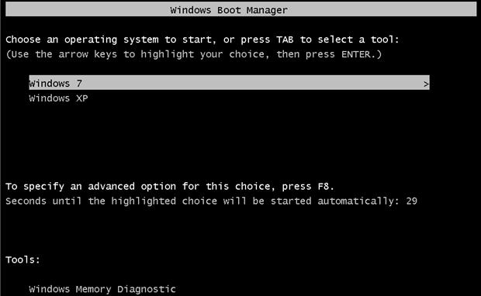

**Result:**

Thus To Assemble a system with add on cards and check the working condition of the system and install OS to the pc are installed successfully.

**4 a)Mobile phone componentsand identification of ICs**

**Aim:**

To identify Mobile Phone Component

1. Basic Mobile Phone Component.

**Antenna:**

**Switch :** It is present in the network selection.This is used to search the network and turn on the network.

**Power :** It is present near the antenna switch.

**Earpiece :** This is used to connect electrical signal.

**Speaker :** This is used to convert electrical into sound**.**

**Buzzer :** This is used to give different audio.

**LCD :**This is used to display the input given by the user.,Menu,settings,contacts ,etc are stored in phone.

**Keyboard :** This is used to give data in the Mobile phone. It is directly connected to the CPU.

**Basic circuit Board Component:**

**Antenna switch :** It is present in the network section this is used to search the network and turn network.

**Power Frequency Oscillator :** It is present near the antenna switch in the network section.

**26MHZ crystalloscillator :** It is the present near PEO. This is used to create Frequency for outgoing calls.

**RX Filter :** It is present in the network section.

**TX Filter :** It is present in the network section.

**RAM :** It is present in a power section.

**ROM :** It is present in the power section.

|  |  |
| --- | --- |
| NAME OF IC | FUNCTIONS |
| **FLASH IC** | Mobile phone software. |
| **POWER IC** | This takes power from battery. |
| **CHARGING IC** | This takes current from charger &battery. |
| **CPU** | This content all section of mobile phones. |
| **LOGIC IC** | This control leringer, literator& Led of phone. |
| **AUDIO IC** | This control speaker and Microphone. |

# 

# RESULT:

# Thus the identification of mobile phone component are done successfully.

**5 a)Assembling and disassembling of a phone**

**Aim:**

1. To assemble and disassemble a Mobile phone Fault, finding of Ear.
2. Place Microphone, keypad, and display sections of mobile phones.

**Requirements:**

* Screwdriver kit
* Mobile phone

**Procedure:**

**Assembling a Mobile phone steps to take when assembling Mobile phone:**

1. Fix the vibrator strips of speaker and volume button.
2. Fix the Motherboard.
3. Connect the antenna with wire.
4. Place the camera and connect it.
5. place the buzzer.
6. Place the camera cover.
7. Make the sure that the LCD is working before you place the screen.
8. Put battery and battery cover.

**Disassembling a Mobile Phone**

1. Steps to take when Disassembling a mobile phone switch off phone.
2. Remove the battery cover.
3. Remove battery,simcard,memory card.
4. Remove all the screws from the phone.
5. Remove strips(buzzer strips,display,camera,volume).
6. Remove the antenna wire from the outside.

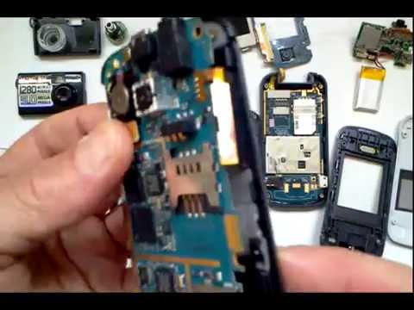

**5 b)Fault finding and troubleshooting of mobile phone**

**Earpiece Earspeaker**

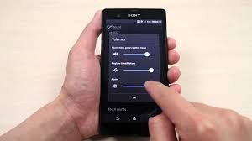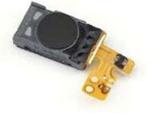

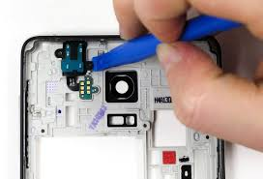

Microphone

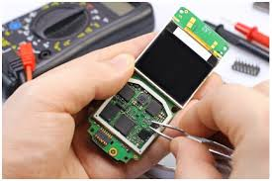

Keypad

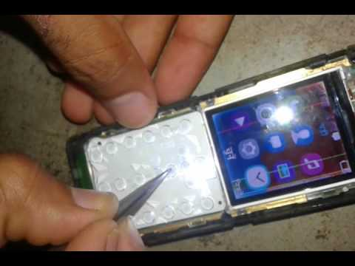

Display section

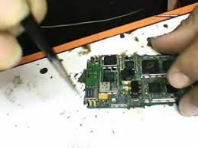

**RESULT:**

Thus the assembling and disassembling of a mobile phone has been completed successfully.

6) **Flashing,unlocking and formatting memory cardsFlashing**

**Aim:**

To perform Flash,Format and unlock a mobile phone.

**Requirements:**

Flashing software,mobilephone,intel core i3 with internet connection

**Procedure:**

It is the process used to overwrite the settings. It is done when the user moves from on service.

1. Download a free software Flash program to the computer.
2. Right click on the downloaded zip and make unzip and save it.
3. Connect the cell phone to the computers.

**Formatting:**

1.To delete all personal data.

2.To remove the viruses.

3.To unlock the phone.

4.Go to setting application.

5.Select backing and reset.

6.Select factory data reset.

7.Select reset device.

8.The phone Power off and Power on itself.

Unlocking Android phone:

1. Connect your phone to computer.
2. Enter in command prompt.
3. Type adb shell rm/data/system/gesture.key”
4. Click enter and reboot your phone.Nowlockscreen would be gone.

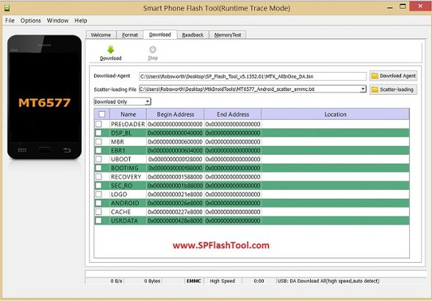

Unlocking

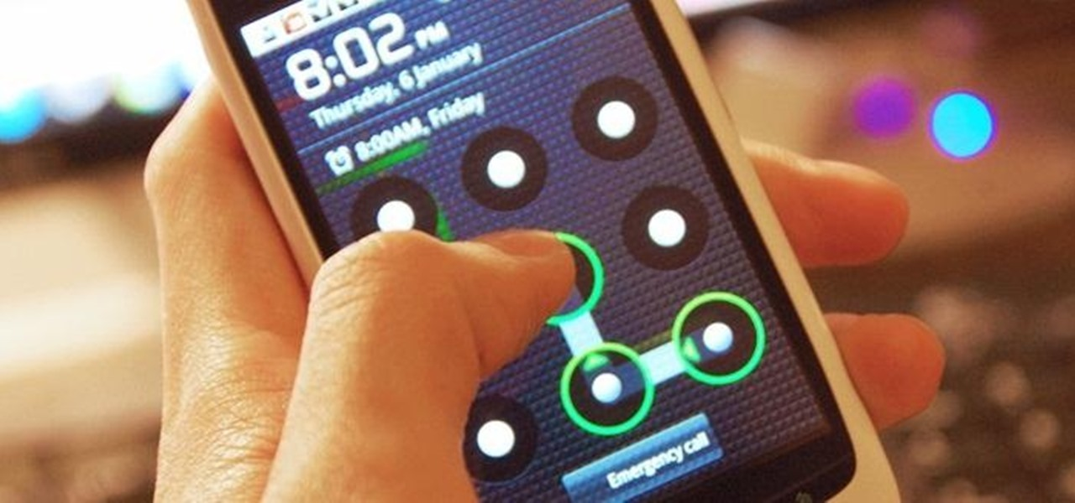

Formatting memory card

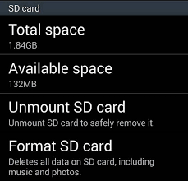

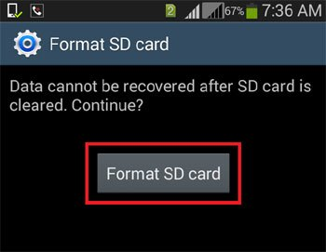

**Result:**

Thus I have performed Flashing,Formatting and Unlocking MobilePhone.

# 7. Do the following Cabling works in a network

* 1. **Cable Crimping b) Standard Cabling and c) CrossCabling**

1. **IO connector crimping e) Testing the crimped cable using acable tester.**

**Aim:**

To do the following

1. CableCrimping
2. StandardCabling
3. Cross Cabling d)IOconnectorcrimping
4. Testing the crimped cable using a cabletester

**Procedure:**

1. **Cable Crimpingsteps:**
   1. Remove the outmost vinyl shield for 12mm at one end of the cable (we call this side A- side).
   2. Arrange the metal wires inparallel
   3. Insert the metal wires into RJ45 connector on keeping the metal wirearrangement.
   4. Set the RJ45 connector (with the cable) on the pliers, and squeeze ittightly.
   5. Make the other side of the cable (we call this side B-side) in the sameway.
   6. 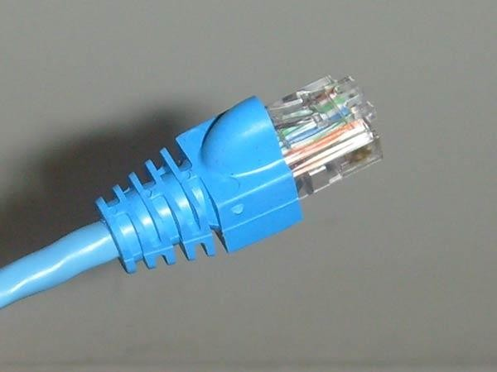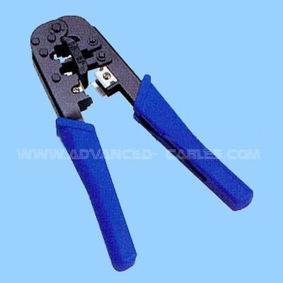Afteryoumadeit,youdon'tneedtotakecareofthedirectionofthecable.

# StandardCabling:

* 1. 10BaseT and 100BaseT are most common mode of LAN. You can use UTP category-5 cable for bothmodes.
  2. A straight cable is used to connect a computer to ahub.

|  |  |  |
| --- | --- | --- |
| in ID | side A | side B |
|  | orang e-white | orang e-white |
|  | orang  e | orang  e |
|  | green-  white | green-  white |
|  | blue | blue |
|  | blue- | blue- |

|  |  |  |
| --- | --- | --- |
|  | white | white |
|  | green | green |
|  | brown  -white | brown  -white |
|  | brown | brown |

# CrossCabling:

A cross cable is used to connect 2 computers directly (with ONLY the UTP cable).

It is also used when you connect 2 hubs with a normal port on both hubs.

|  |  |  |  |  |
| --- | --- | --- | --- | --- |
| in ID | e A | sid | e B | sid |
|  | nge- white | ora | een- white | gr |
|  | nge | ora | een | gr |
|  | gre en-white | | ange- white | or |
|  | e | blu | e | blu |

|  |  |  |
| --- | --- | --- |
|  | blu e-white | blu e-white |
|  | gre  en | or  ange |
|  | bro wn-white | br own- white |
|  | bro  wn | br  own |

# StandardCablingconnector: Cross Cablingconnector:

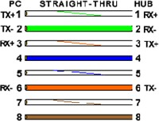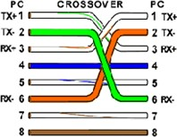

1. **IO connector crimping: Run the full length of Ethernet cable in place, from endpoint to endpoint, making sure to leaveexcess.**

* At one end, cut the wire to length leaving enough length to work, but not too much excess.
* Strip off about 2 inches of the Ethernet cablesheath.
* Align each of the colored wires according to the layout of thejack.
* Use the punch down tool to insert each wire into thejack.
* Repeat the above steps for the second RJ45jack.

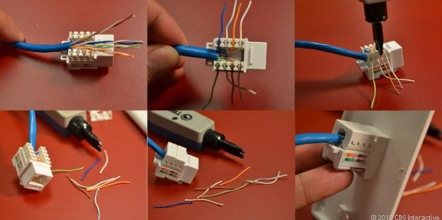

# Testing the crimped cable using a cabletester:

* 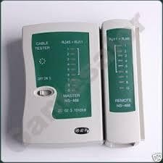cable crimping and testing RJ45 cable tester crimper cable stripper UTP cableconnector
* Type of cable straight cable crossedcable
* Straight cable PC toHUB
* Crossed cable pc to pc hub to hub 568B 568A WiringSchematic
* Analogy 568B GO AND BUY ORANGE, BROWN568A
* Straight through cable for a straight through cable, both ends use the same wiring schematics. 568B568B
* Crossover cable for a crossover cable, both ends uses different wiring schematics. 568A 568B pair twisted wire RJ45connector
* Step 1 : Skin off the cable jacket 3.0 cm long cable stripper up tocable
* Step 2: Untwist each pair and straighten each wire 190 0 1.5 cmlong.
* Step 3 : Cut all thewires
* Step 4 : Insert the wires into the RJ45 connector right white orange left brown the pins facingup
* Step 5 : Place the connector into a crimping tool, and squeeze hard so that the handle reaches its fullswing.
* Step 6: Use a cable tester to test for propercontinuity.

**Result:**

Thus the Cable Crimping, Standard Cabling and Cross Cabling, IO connector crimping and testing the crimped cable using a cable tester are done successfully

**8)A)Configure Host IP, Subnet Mask And Default Gateway In a System In LAN(TCP/IP Configuration)**

**Aim:**

To configure IP address in a system in LAN(TCP/IPcconfiguration) and configure DNS to establish interconnection between systems.

**Principle:**

**Following is required to be study under this practical**

**Classification of IP addresss:**

|  |  |  |
| --- | --- | --- |
| **class** | **Address Range** | **Supports** |
| **Class A** | **1.0.0.1 to 126.255.255.254** | **Supports 1.6 million hosts on each of 127 networks.** |
| **Class B** | **128.1.0.1 to 191.255.255.254** | **Supports 65,000 hosts on each of 16000 networks** |
| **Class C** | **192.0.1.1 to 223.255.254.254** | **Supports 254 hosts on each of 2 million networks** |
| **Class D** | **224.0.0.0 to 254.255.255.254** | **Reserved for multicase groups** |
| **Class E** | **240.0.0.0 to 254.255.255.254** | **Reserved for future use or Research & development purposes** |

Procedure:

1. **Steps to configure IP address,Subnet mask and default Gateway**:
   1. Click on the start button and select control panel then Network and internet connection.
   2. Click network and internet connection.
   3. Right click on the local area connection icon & select properties.
   4. Select internet protocol(TCP/IP).
   5. Click on the properties button.
   6. Ensure that register this connections address is DNS not selected
   7. Click ok then close all Boxes.

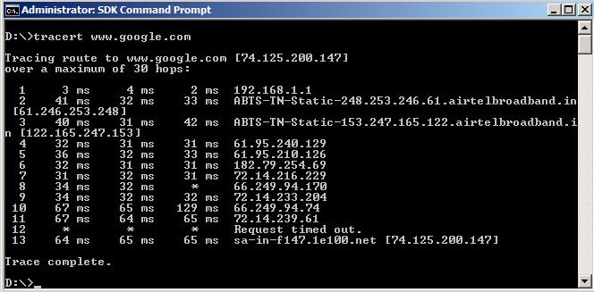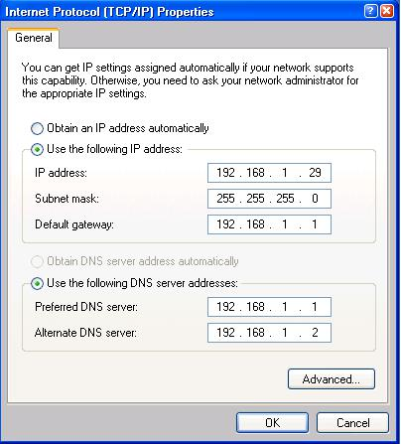

**TRACERT**

**RESULT:**

Thus the configuration of IP Address in a system in LAN and configuration to establish interconnection between systems have been done successfully.

# 8(B).Configure Internet connection and use IPCONFIG, PING / Tracer

**And Netstat utilities to debug the network issues.**

**Aim:**

To Configure to Configure Internet connection and use IPCONFIG, PING / Tracer and Net stat utilities to debug the network issues establish interconnection between systems

**Procedure:**

**Configure Internet connection and use IPCONFIG, PING:**

1. OpenCommand Prompt, and then type **ipconfig**. From the display of the **ipconfig**command, ensure that the network adapter for the TCP/IP configuration you are testing is not in a **Media disconnected**state.
2. At the command prompt, ping the loopback address by typing **ping127.0.0.1**.
3. Ping theIP addressof thecomputer.
4. Ping the IP address of the defaultgateway.
   * If the **ping** command fails, verify that the default gateway IP address is correct and that the gateway (router) isoperational.
5. Ping the IP address of a remote host (a host that is on a differentsubnet).

If the **ping** command fails, verify that the remote host IP address is correct, that the remote host is operational, and that all of the gateways (routers) between this computer and the remote host are operational.

1. Ping the IP address of theDNSserver.

If the **ping** command fails, verify that the DNS server IP address is correct, that the DNS server is operational, and that all of the gateways (routers) between this computer and the DNS server areoperational.

# Tracer and Net stat utilities to debug the network issues. Tracer network:

* OpenCommand Prompt, and type thefollowing:
* tracerthost_name

Or, type tracertip_address

* wherehost_name or ip_address is the host name orIP address, respectively, of the remotecomputer.
* For example, to trace a connection route from this computer to [www.microsoft.com,](http://www.microsoft.com/) type the following at a commandprompt:

tracert[www.microsoft.com](http://www.microsoft.com/)

* If you do not want the tracert command to resolve and display the names of all routers in the path, use the -d parameter. This expedites the display of the path. For example, to trace a path from this computer to [www.microsoft.com](http://www.microsoft.com/) without displaying the router names, type the following at a commandprompt:

**Net stat utilities to debug the network issues:**

Displays active TCP connections, ports on which the computer is listening, Ethernet statistics, the IP routing table, IPv4 statistics (for the IP, ICMP, TCP, and UDP protocols), and IPv6 statistics (for the IPv6, ICMPv6, TCP over IPv6, and UDP over IPv6 protocols). Used without parameters, **netstat**displays active TCP connections.

**Syntax**

**netstat**[**-a**] [**-e**] [**-n**] [**-o**] [**-p** *Protocol*] [**-r**] [**-s**] [*Interval*]

# Parameters

**-a**

Displays all active TCP connections and the TCP and UDP ports on which the computer is listening.

# -e

Displays Ethernet statistics, such as the number of bytes and packets sent and received. This parameter can be combined with **-s**.

# -n

Displays active TCP connections, however, addresses and port numbers are expressed numerically and no attempt is made to determine names.

# -o

Displays active TCP connections and includes the process ID (PID) for each connection. You can find the application based on the PID on the **Processes** tab in Windows Task Manager. This parameter can be combined with **-a**, **-n**, and**-p**.

**-p** *Protocol*

Shows connections for the protocol specified by *Protocol*. In this case, the *Protocol* can be **tcp**, **udp**, **tcpv6**, or **udpv6**. If this parameter is used with **-s** to display statistics by protocol, *Protocol* can be **tcp**, **udp**, **icmp**, **ip**, **tcpv6**, **udpv6**, **icmpv6**, or **ipv6**.

# -s

Displays statistics by protocol. By default, statistics are shown for the TCP, UDP, ICMP, and IP protocols. If the IPv6 protocol for Windows XP is installed, statistics are shown for the TCP over IPv6, UDP over IPv6, ICMPv6, and IPv6 protocols. The **-p** parameter can be used to specify a set of protocols.

# -r

Displays the contents of the IP routing table. This is equivalent to the **route print** command.

## Interval

Redisplays the selected information every *Interval* seconds. Press CTRL+C to stop the redisplay. If this parameter is omitted, **netstat**prints the selected information onlyonce.

# /?

Displays help at the command prompt.

**PING IPCONFIG**

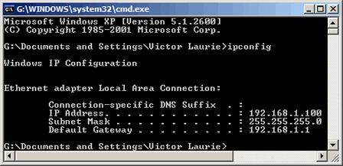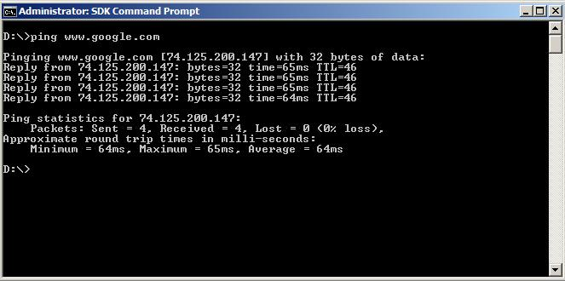

**NETSTAT**

## 

## Result:

Thus the Configure Internet connection and use IPCONFIG, PING/Tracer and

Net stat utilities to establish interconnection between systems have been done successfully

# Ex. No. 9.Install and configure Network Devices: HUB, Switch and Routers.

**Aim:**

To Install and configure Network Devices HUB, Switch and Routers PCs are interfaced using connectivity devices.

**Procedure:**

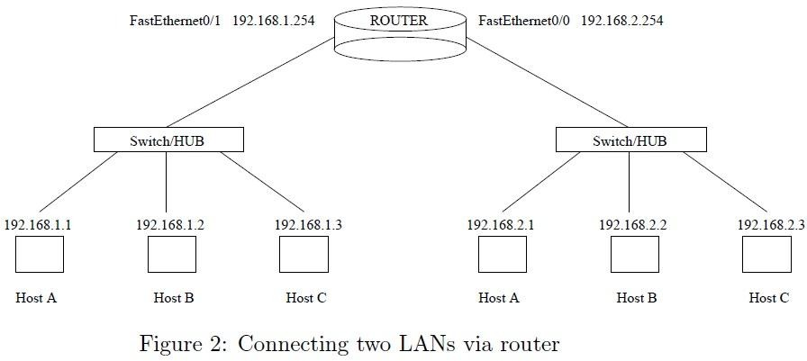

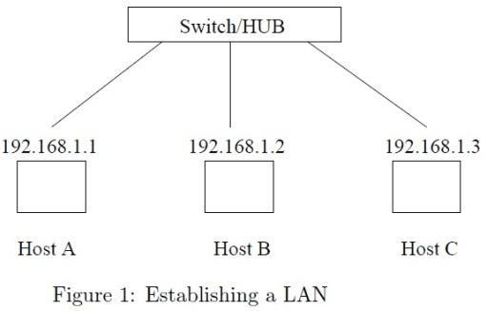

**Result**

Thus install and configure Network Devices PCs are interfaced using connectivity devices – Hub, router and switch have been done successfully.

# Ex.No:9 b. Install and Configure Wired and Wireless NIC and transfer files between systems in LAN and Wireless LAN.

## Aim:

*To* Install and Configure Wired and Wireless (remotely) NIC and transfer files between systems in LAN and Wireless LAN between two system in a LAN.

**Procedure:**

1. **Install the networkcard:**

Disconnect all cables connected to the computer and open the case.

* + Locate an available PCI slot (white slots) and insert the network card and secure the card with the screw that came withit.
  + Once the adapter has been installed and secured close the computer case, connect all the cables and turn iton.
  + Once your computer is on install the adapter driver by inserting the CD that came with the Ethernetadapter.
  + After installing the adapter driver it should be working find, now let’s configure the card for use on anetwork.
  + Click on the Start button and select Settings then ControlPanel.
  + Double click on the Systemicon.
  + Click on the Hardwaretab.
  + Click on DeviceManager.
  + You will see a list of devices installed in yourcomputer.
  + If necessary, click on the + sign next to Network Adapters to expand thelist.
  + Ensure that there is no yellow exclamation mark (!) next to the Network Adapter. This indicates a possible problem with the card orconfiguration.
  + Double click on your network driver (e.g. NE2000Compatible).
  + In the Device Status box you should see themessage:
  + This Device is workingcorrectly.

If you do not see this message or if there is no Network Adapter displayed, then your Ethernet card will probably need configuring.

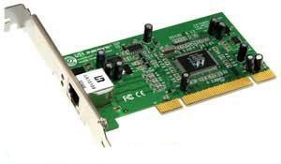**NICs (Network Interface Card):**Network Interface Card, or NIC is a hardware card installed in a computer so it can

communicate on a network.Thenetwork adapter

provides one or more ports for the network

cable to connect to, and it transmitsand receives data onto the networkcable.

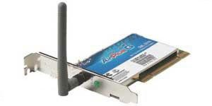**Wireless LAN card:**

Every networked computer must also have a

network adapter driver, which controls the

network adapter. Eachnetworkadapter driver is

configuredtorunwithacertaintypeof network adapter.

**Result:**

Thus Installation and configuration of Wired and Wireless (remotely) NIC and transfer files between systems in LAN and Wireless LAN between two systems in a LAN have been done successfully.

# Ex : 10 Transfer files between systems in LAN using FTP Configuration, install Print server in a LAN and share the printer in a network.

## Aim:

*To t*ransfer files between systems in LAN using FTP Configuration, installPrint

server in a LAN and share the between two system in a LAN.

**Procedure:**

**Local Printer installs:**

**To Install and configure printer:**

* + Connect the printer to parallel port of the motherboard and power cable toAC.
  + Switch on the system andprinter.
  + Insert the driver disk in the CDdrive.
* Click **start >control panel**>**printers and fax**respectively.
* Then **>double click**>**add a printer>add printer wizard**respectively.

# Printer sharing:

1. Open Printers and Faxes. Click **Start**, click **Control Panel**, click **Printers and Other Hardware**, and then click **Printers andFaxes**.
2. Right-click the printer you want to share, and then click**Sharing**.
3. On the **Sharing** tab, click **Share this printer** and then type a **share name** for the sharedprinter.

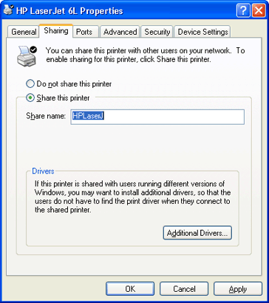

1. If you share the printer with others using different hardware or different operating systems, click **Additional Drivers**. Click the **Environment** and operating system for the other computers, and then click **OK** to install the additionaldrivers.

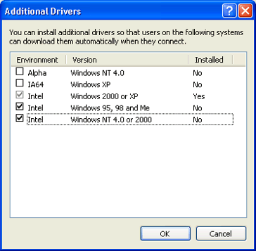

1. Click **OK**, or, if you have installed additional drivers, click **Close**. **To stop sharing yourprinter:**
2. Open Printers and Faxes. Click **Start**, click **Control Panel**, click **Printers and Other Hardware**, and then click **Printers andFaxes**.
3. Right-click the printer you want to stop sharing, and then click**Sharing**.
4. On the **Sharing** tab, click **Do Not share this printer**. **To connect to a printer on anetwork:**
5. Open Printers and Faxes. Click **Start**, click **Control Panel**, click **Printers and Other Hardware**, and then click **Printers andFaxes**.
6. Under **Printer Tasks**, click **Add a printer** to open the **Add Printer Wizard**, and then click**Next**.
7. Click **A network printer, or a printer attached to another computer**, and thenclick

# Next.

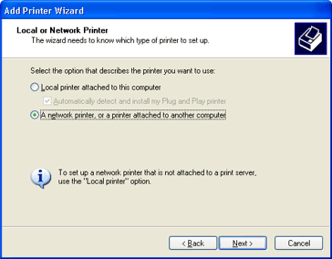

**Three Ways to Connect to a Printer on a Network:**

To search for a printer in Active Directory

1. 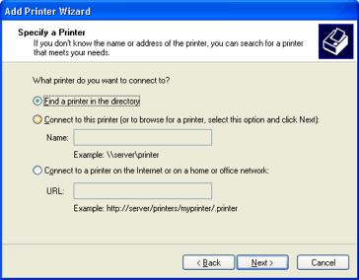Click **Find a printer in the directory**, and then click**Next**.
2. Click the **Browse** button to the right of **Location**, click the printer location, and then click**OK**.

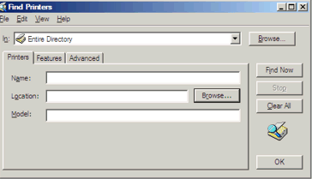

1. Click **FindNow**.
2. Click the printer you want to connect to, and then click**OK**.

# To locate a printer by typing the printer name or browsing for it

1. 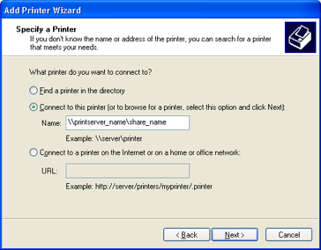Click **Connect to thisprinter**.
2. Do one of thefollowing:
   * Type the printer name using the followingformat:

\\printserver_name\share_name

* + 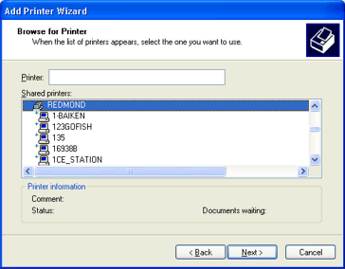Browse for it on the network. Click **Next**, click the printer in **Sharedprinters**.

1. Click Next.

**Result:**

Thus To transfer files between systems in LAN using FTP Configuration, installPrint

server in a LAN and share the between two system in a LAN.

**SYSTEM ADMINSITRATION PRACTICAL**

**EX NO: 1 Windows Server 2008 Installation**

**Aim**

To install windows server 2008.

**Hardware requirement :**

Intel core i3 cpu with system

**Software requirement :**

Windows server 2008 CD

**Procedure**

**Steps to install Windows Server 2008 :**

**Windows Server 2008**

1. Insert the Windows Server 2008 installation DVD

2. Reboot the system

3. Select the language, regional settings and keyboard layout that are correct for your system and Click Next

4. Click Install Now

5. Select the Windows Server 2008 Enterprise (Full Installation) and Click Next

6. Select the I Accept The License Terms check box and click Next

7. Click Custom from which type of installation do you want?.

8. Select first disk usually disk 0 to install OS. Full OS approximately takes 10 GB of hard drive space.

9. Click Next

10. Click OK . Press ctrl +alt +del to login.

11. Type an Administrator Password and Confirm it. (Password)

12. Click OK

**Installation of windows server 2008**









Result :

Thus the installation of windows server 2008 has been completed successfully.

**EX NO: 2 Install hardware ,device driver using devicemanager**

**Aim**

**To install hardware, devices and drivers using devicemanager.**

**Hardware requirements:**

* Bio metric device
* Intel core cpu with system

**Software requirements:**

* Windows server 2008
* Bio metric device driver CD

**Procedure :**

1. Connect biometric device using usb port.
2. Install device driver for biometric using devicemanager.

**Methods of installing device drivers**

Admins can install device drivers on a server in four ways.

1. Running the Setup. Device drivers are automatically installed for all detected devices during installation of Windows 2008 system on the server computer
2. Starting the computer. Whenever the server is started, new devices are detected and their device drivers are automatically installed
3. Scanning for new hardware.Add/Remove Hardware Wizard can be used to perform the hardware-detection process and desired device driver installation
4. Manual installation. You can use the Add/Remove Hardware Wizard to specify the device you want to install, or you can right-click the .INF file that comes with the driver and choose Install.

**Run devicemanager**

Start Device manager by typing 'Devmgmt.msc' in the Run dialog box.

**Configuring devices using Device Manager**

Device Manager displays information about all devices installed on your server. It displays a list of devices that were either detected or for which drivers are installed.

* Normal icon indicates that the device driver has initialized successfully.
* Exclamation point on icon would mean that device is incorrectly configured.
* Stop sign on icon means that device could not be initialized due to hardware conflicts.

**Updating and removing device drivers**

**To update a device driver:**

1. Start Device Manager by typing 'Devmgmt.msc' in the Run dialog box.
2. Right-click the desired device and select Properties.
3. Click the 'Driver' tab and then click the Update Driver button.

**To remove a device:**

1. Start Device Manager by typing 'Devmgmt.msc' in the Run dialog box.
2. Right-click the desired device and select Properties.
3. Click the 'Driver' tab and then click Uninstall button

**Note**: Removing the device does not actually delete the device driver itself. What it does is remove references to the driver from the Registry so that the computer does not load the driver.

**Installing hardware devices and drives**

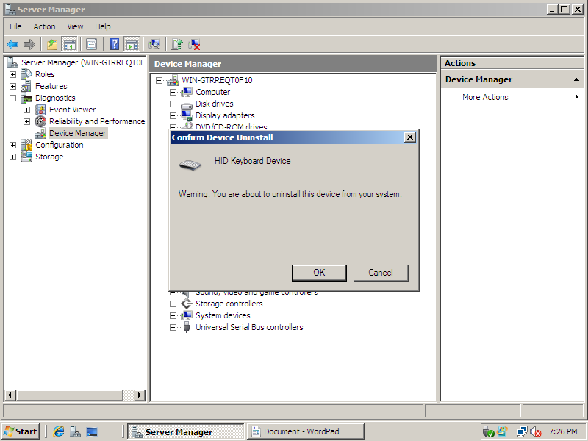

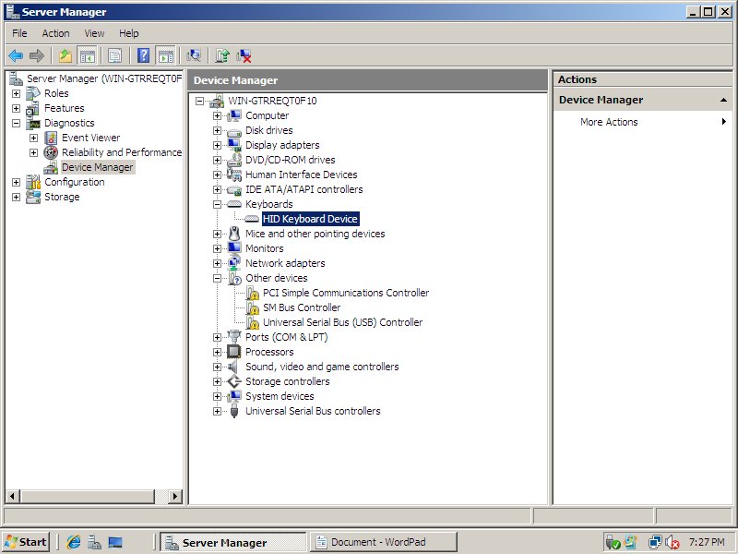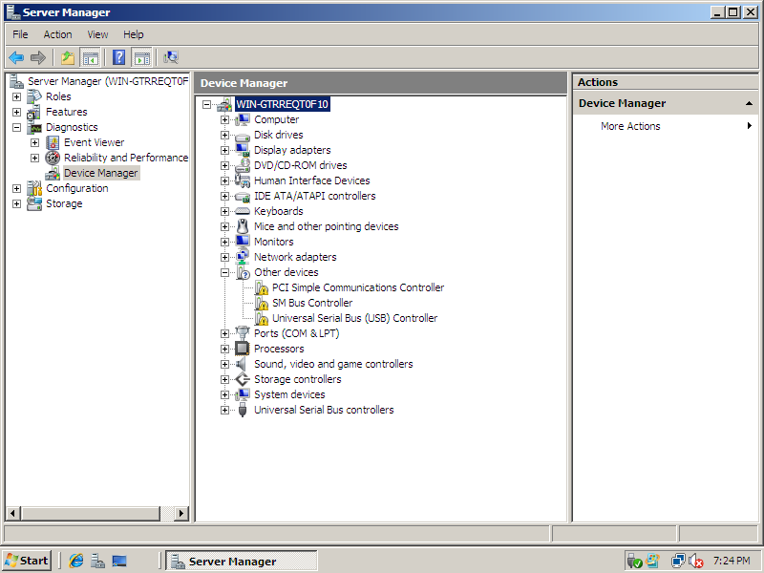

**Result:**

Thus the installation of devices using device manager completed successfully.

**Ex.No.3** **Active Directory Services**

**Aim**

To configure active directory services , create a user and assign permission using logon script and group permissions.

**Requirements:**

* Intel core i3 system with windows server 2008
* Intel core i3 system wtith windows7

**Procedure**

**Installation of active directory service**

1. Open Server Manager and click on roles.select Add Roles
2. Select Active Directory Domain Services from the list. Click add some feature and select Add Required Features button and click next to move on.
3. Click next and select install to start installing Active Directory.

**Configuration**

1. Start ->run . Type dcpromo
2. Select create new forest from active directory wizard. Give domain name as computer.com and click next and select Widnows Server 2008 .
3. click next and click yes to continue. . restart the system .

**CREATE USER**

1. Click on **Start**→ Administrative tools → Active Directory User and Computers .
2. Expand Domain name tree **(computer.com** ) then **Right -click** on **Users** then Click on **New** and then click on **User .**
3. On the New Object-User windows , Type **First name , initials , last name** and then Give the **User Logon name** . then Click on **Next .**
4. Now Type **Password** and then confirm **Password** .
5. Create another user just as above .create group and add these two users and under that group.

**Assign Permissions Using Logon :**

1. Create share folder name as test in c: .select properties and click share and set select group name and set permissions as reader and click done. Here , Users and group can only read the files from the server.
2. Type **net use f:** **\\server1\test** in command prompt where server1 as computername and test as sharedname.
3. Mark the command and paste into notepad and save as script.bat under desktop. Copy this file under c:\test.
4. Select start -> administrative tools -> group policy management .
5. Click default domain policy and right click and go to editor.
6. Select startup option from windows settings and select script.bat file by clicking add file option.
7. Go to command prompt and type **gpupdate /force .**now permissions are updated.

**Testing ADS**

1. Set Client ip address as other than server. And give server ip address in dns server.
2. Go to Computer and select change settings as domain and give computer.com.
3. Select network and access shared folder to check the permissions.

**Active directory Service installation**

**co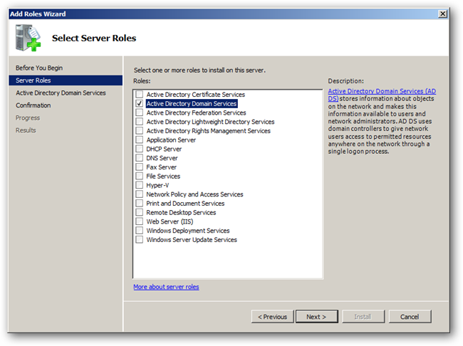nfiguration of ADS**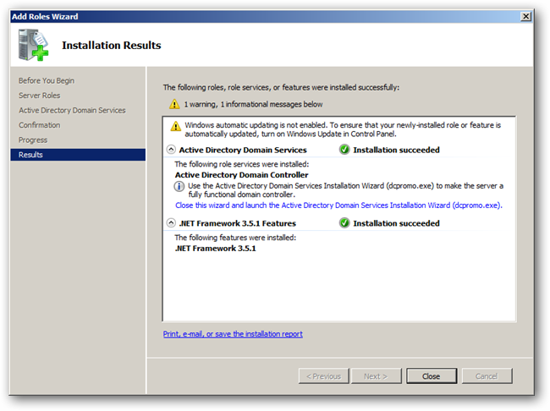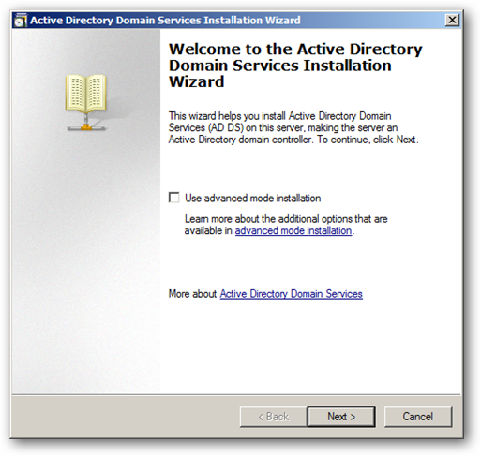

**configuration of ADS Creation of user and groups**

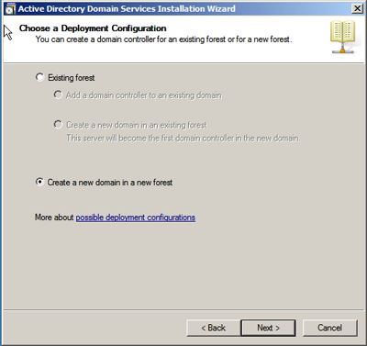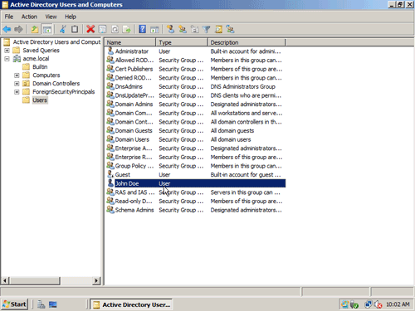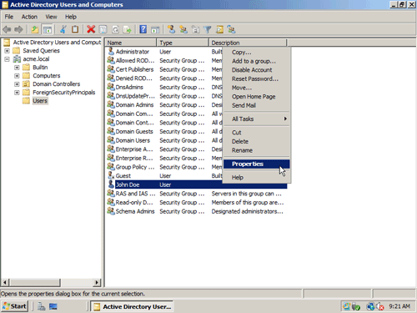

**Creation of logon script Assign permissions using logon script**

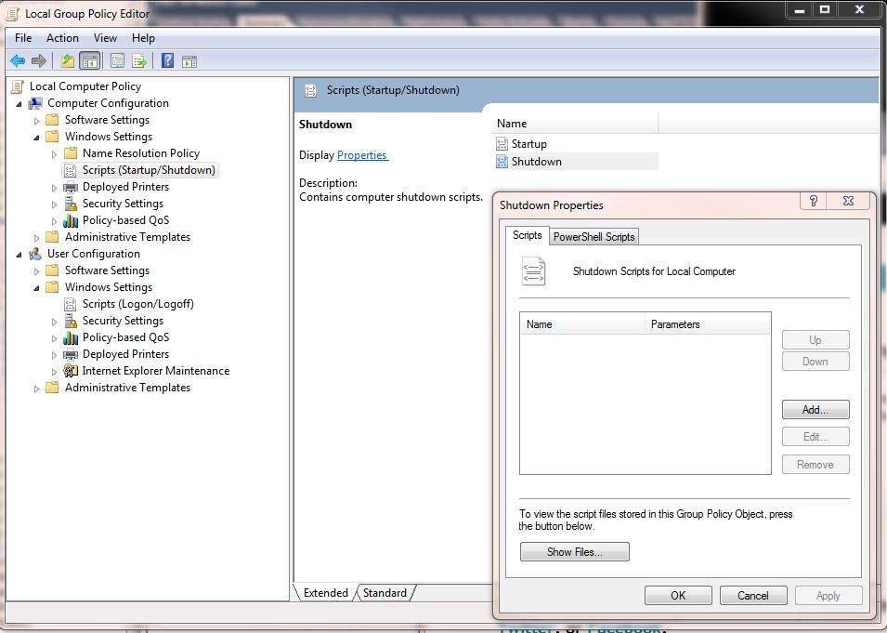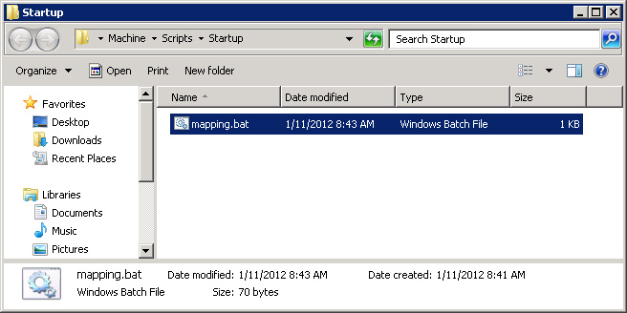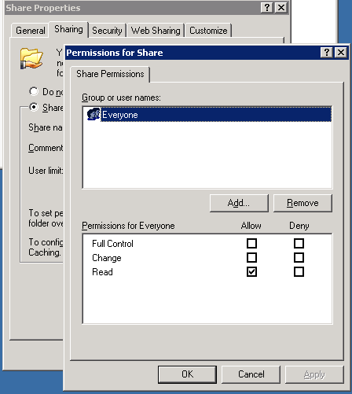

**Accessing shared folder Configuring network for Domain configuring network for client**

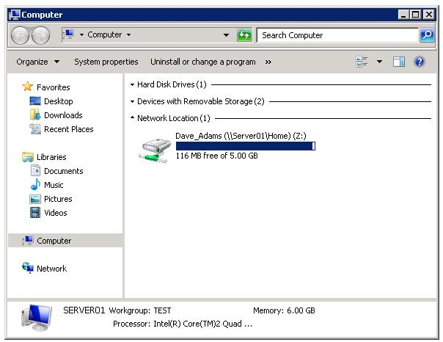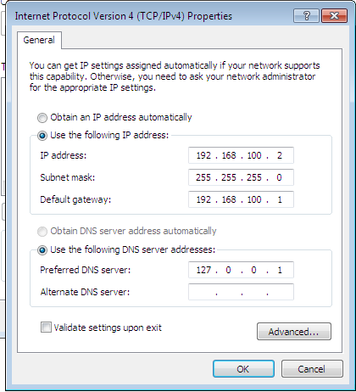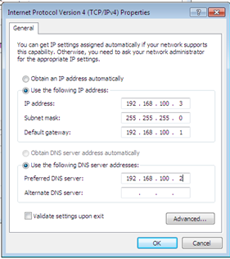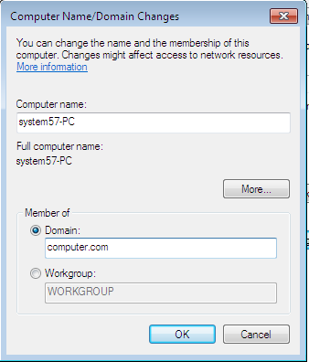

**Result**

Thus the configuration of active directory services , creation of user and assign permission using logon script and group permissions has been completed successfully.

**Ex.No.4 DHCP Server Installation and Configuration**

**Aim**

To install and configure DHCP Server.

**Requirements:**

* Intel core i3 system with windows server 2008
* Intel core i3 system wtith windows7

**Procedure**

**DHCP Installation**

1. Open Server Manager . Right click on roles, and then select add roles. Select DHCP Server.
2. Type network binding address. (example 192.168.100.4)
3. Put in the IP address of your DNS Server (127.0.0.1)
4. Click next again to skip the WINS setup.
5. Click next and add scope. Enter as below

|  |  |
| --- | --- |
| Start ip | 192.168.100.1 |
| End ip | 192.168.100.254 |
| Subnet mask | 255.255.255.0 |
| Gateway | 192.168.100.2 |

1. click next and select disable option. Then click install. Finally restart the system.

**Configuration**

1. select DHCP server from server manager.
2. Select address pool from IPV4 and set exclusion as

|  |  |
| --- | --- |
| Start ip | 192.168.100.1 |
| End ip | 192.168.100.5 |

1. Select router and give ip as 192.168.100.1

**Testing DHCP server**

1. Connect DHCP server system with client.
2. Set network setting of client as obtain ip address automatically.
3. Restart client.
4. Now ipaddress is set by dhcp server and we can confirm with by typing ipconfig at command prompt.

**DHCP Server Installation**

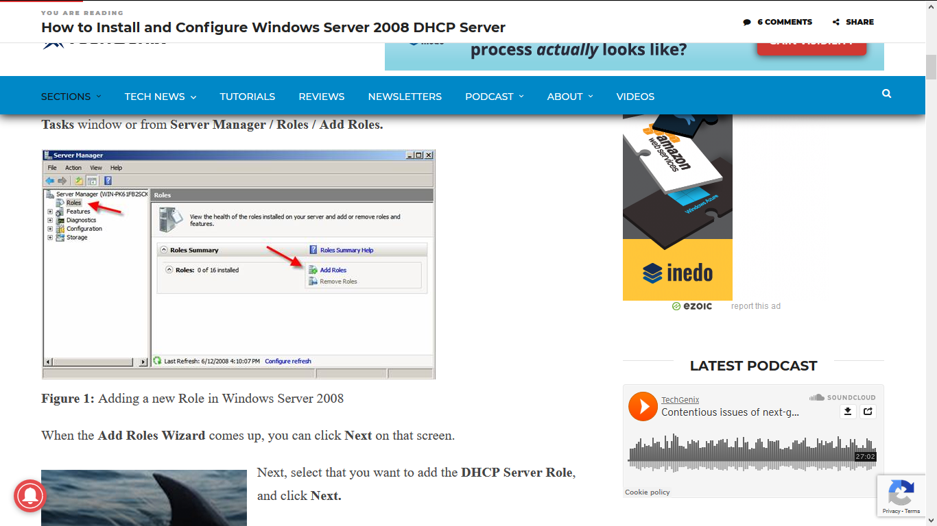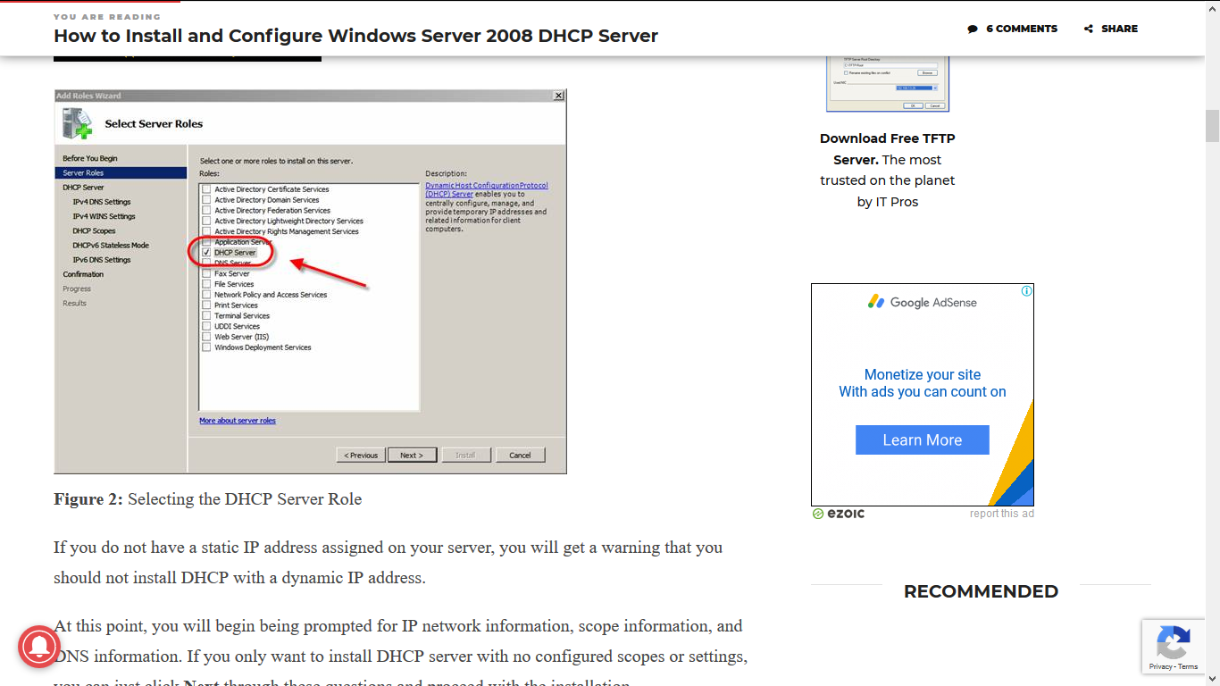

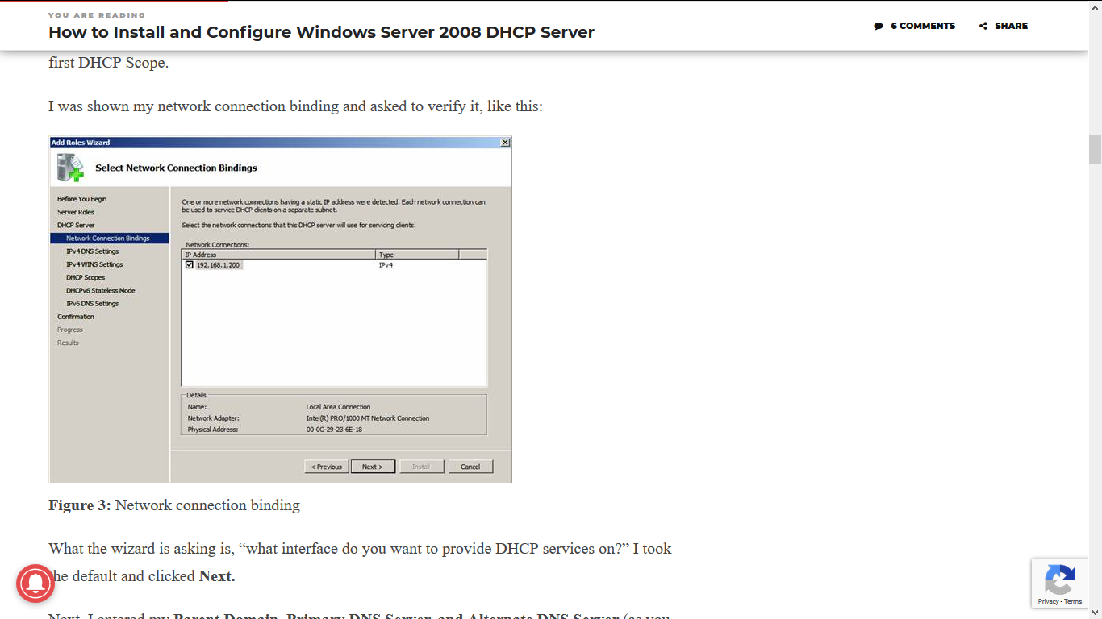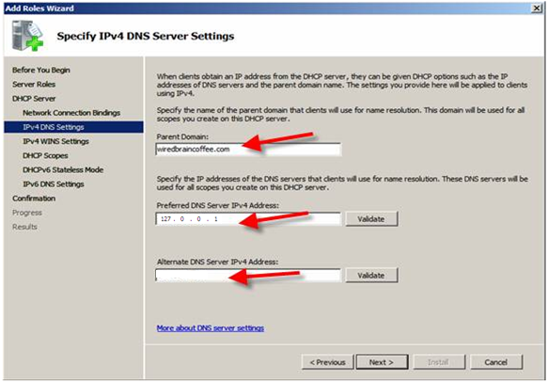

**DHCP Server Installation**

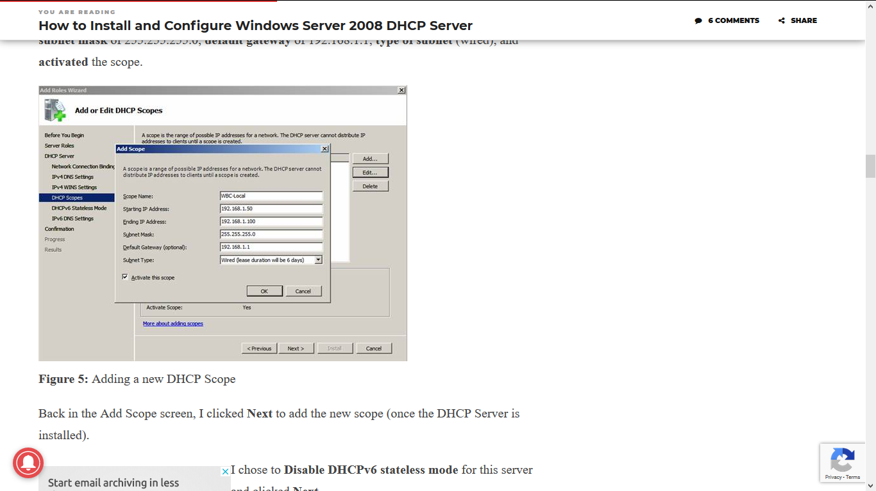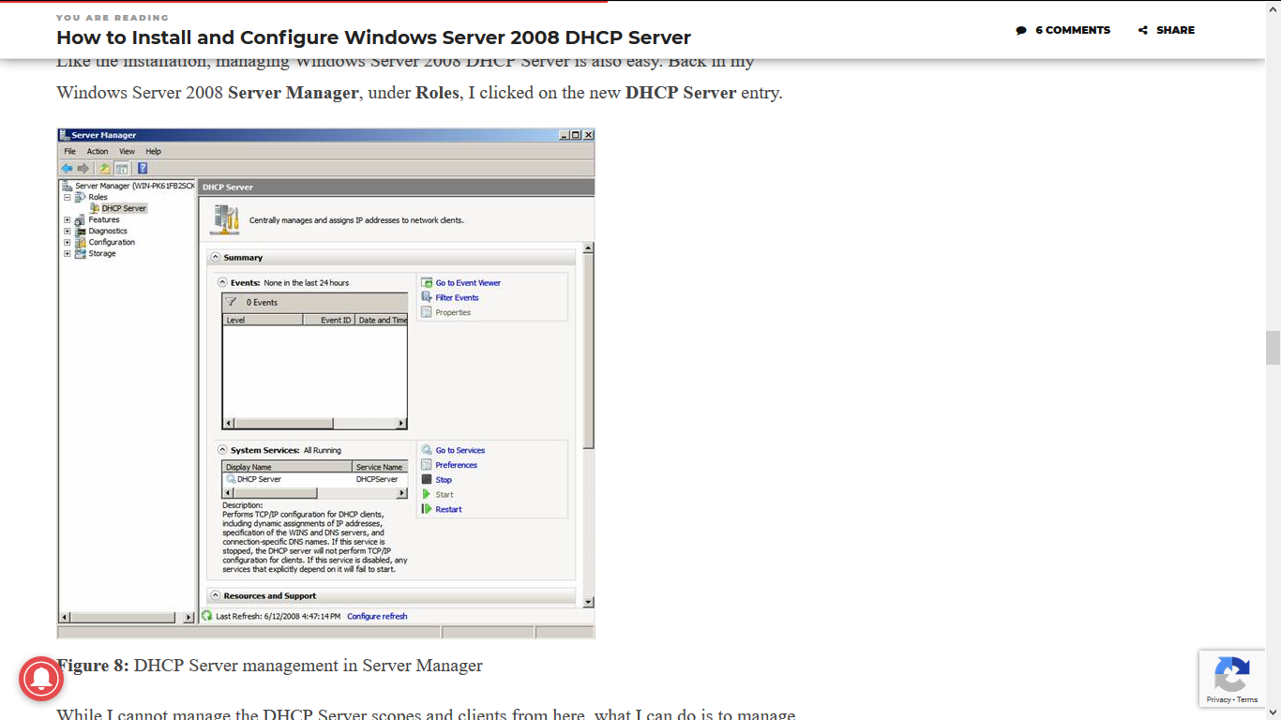

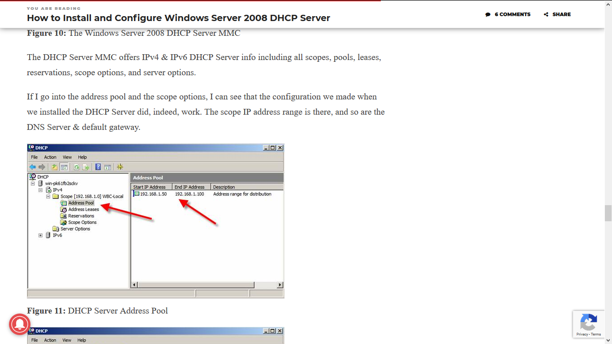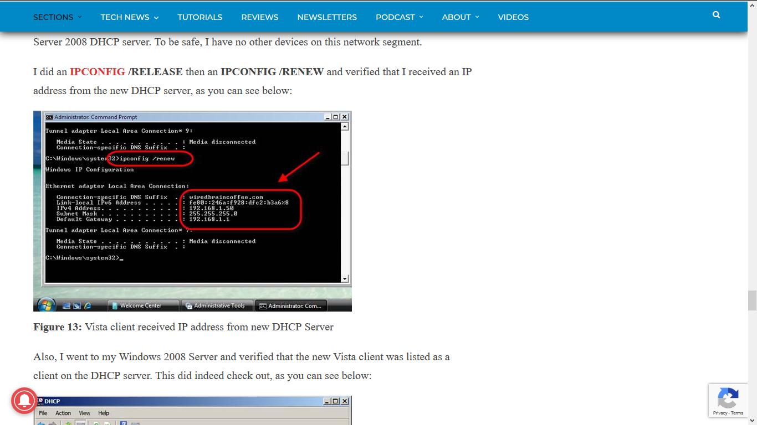

**Result**

Thus the installation and configuration of DHCP server has been completed successfully.

**Ex.No.5 Mail Server Installation and Configuration**

**Aim**

To install and configure mail server.

**Requirements:**

* Intel core i3 system with windows server 2008
* Intel core i3 system wtith windows7

**Procedure**

**Installing the SMTP feature**

**1**. select **Server Manager**:

**2**. Right click on **Features** and click **Add Feature**: select **SMTP Server .**click next

**3**. Click **Add Required Role Services and** Ensure **SMTP Server** is checked then click **Next.**

**4**. **IIS 6 Metabase Compatibility** and **IIS 6 Management Console** should also be checked. Click **Next** to continue:

**5**. In the **Confirmation** section ,click **Install** and close.

**Configuring the SMTP Server**

The next step is to configure **SMTP**. To do so we will need to open **Internet InformationServices (IIS) Manager 6**.

**1**. Click **Start** > **Administrative tools ->**open **Internet InformationServices (IIS) Manager 6**.

**2**. In **IIS 6 Manager** right-click on **SMTP Server** and select **Properties**:

**3**. In the **General** tab, unless you want the **SMTP Server** to use a specific IP address, leavethe settings as they are so that the **IP address** is set to **(All Unassigned)**:

4.click on the **Access** tab and Click on the **Authentication** button and ensure **Anonymous access** is checked and thenclick**OK**

**5**. Once back in the **Access** tab, click on the **Connection** button. Select**Only the list below** and then click **Add**. Enter **127.0.0.1** as the IP addess and then click **OK**:

**6**. Select **Relay** button from access tab. Enter **127.0.0.1** as the IP addess and then click **OK**:

**7**. Next, go to the **Messages** tab. enter an email address for non-delivery reports . Also configure the location of the **Badmail** directory.

**8**. Next, go to the **Delivery** tab. Click on the **Outbound Security** button and ensure **Anonymous access** is selected.

**9** .click on **Outbound Connections** in delivery tab, thenclick on the **Advanced** button. Enter domain name of SMTP server. Check DNS to validate the entry.

**10.** Click**OK** 2 times.

**Start SMTP Server automatically**

1. Type services in search box, select smtp service and right click and select properties and select automatic in starttype of general tab.

**Testing the SMTP Server**

To test SMTP server, we need telnet client. Install telnet client feature from add features in server manager.

1. Start -> run ->cmd
2. Type **telnetlocalhost 25**to send mail.
3. Type **helo me** to check response
4. Type **mail from: your email id.**
5. Type **rcpt to: receiver email id.**
6. Type **DATA** to enter message
7. Type the message and ends with ‘**.**’
8. It replies the delivery report.

**MAIL SERVER INSTALLATION**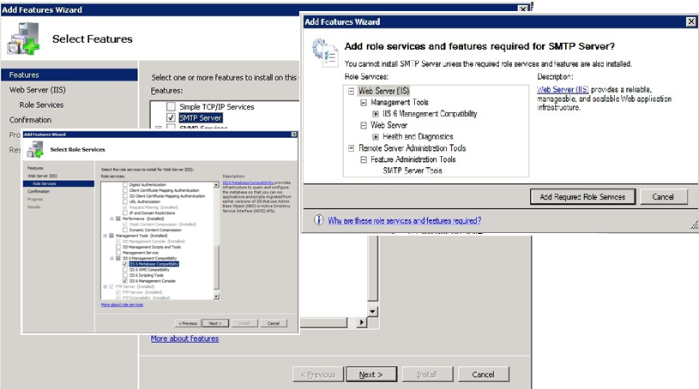

**Configuration of SMTP server**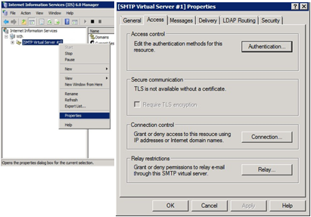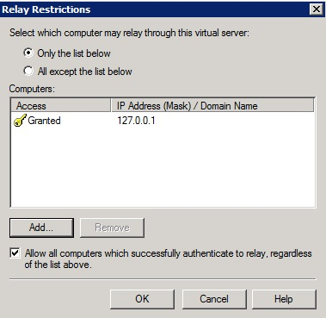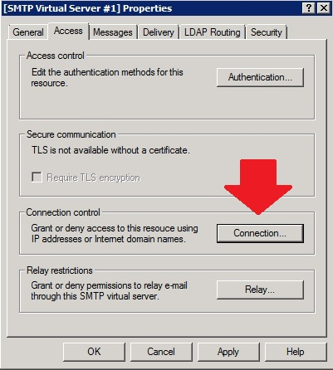

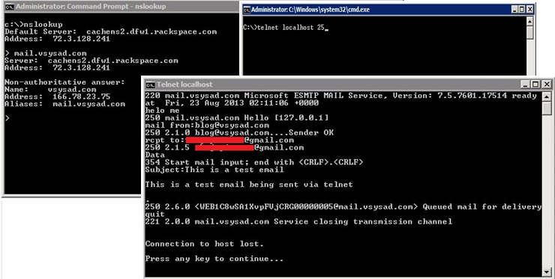**TESTING MAIL SERVER**

**Result**

Thus the installation and configuration of mail server has been completed successfully.

**Installation of redhatlinux in graphical mode**

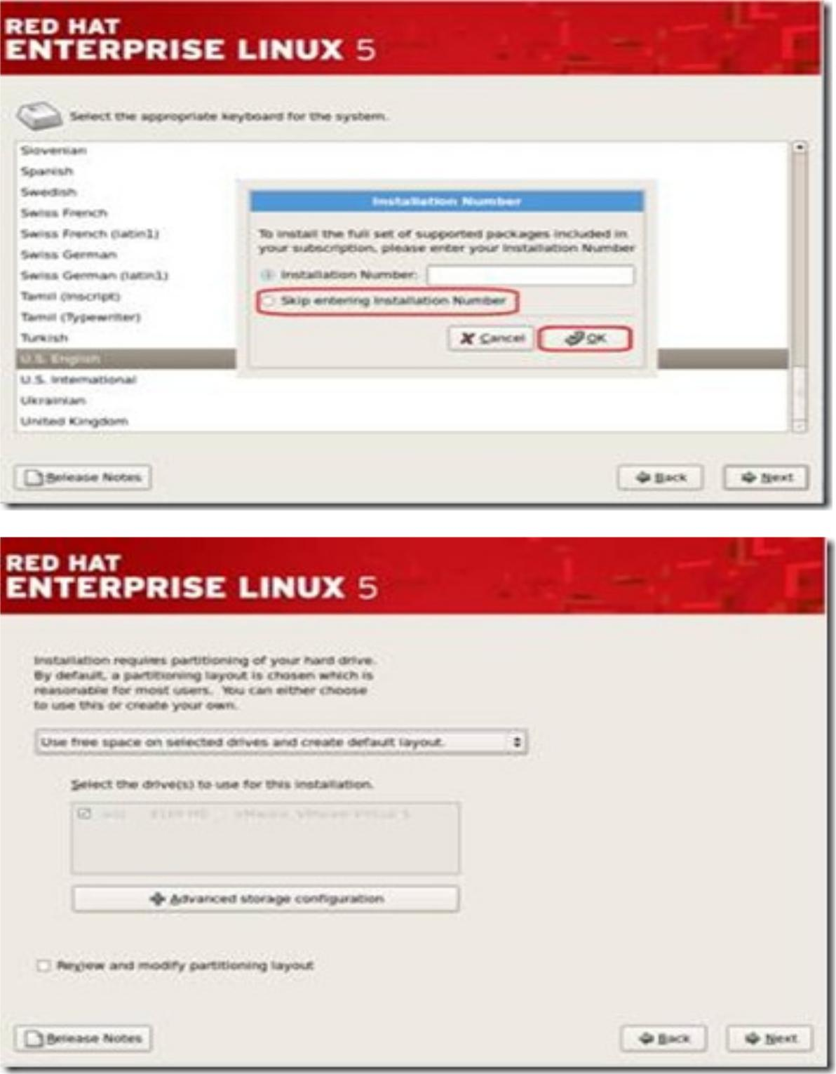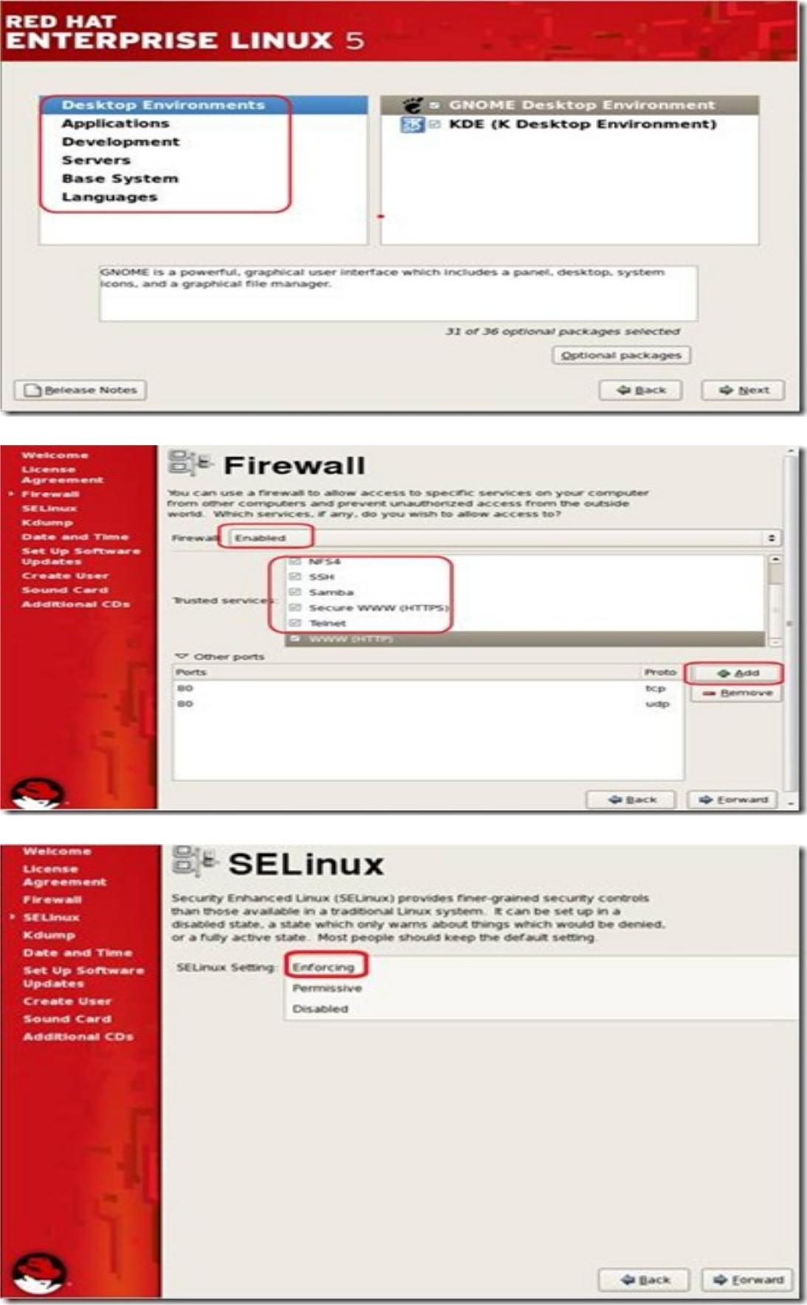

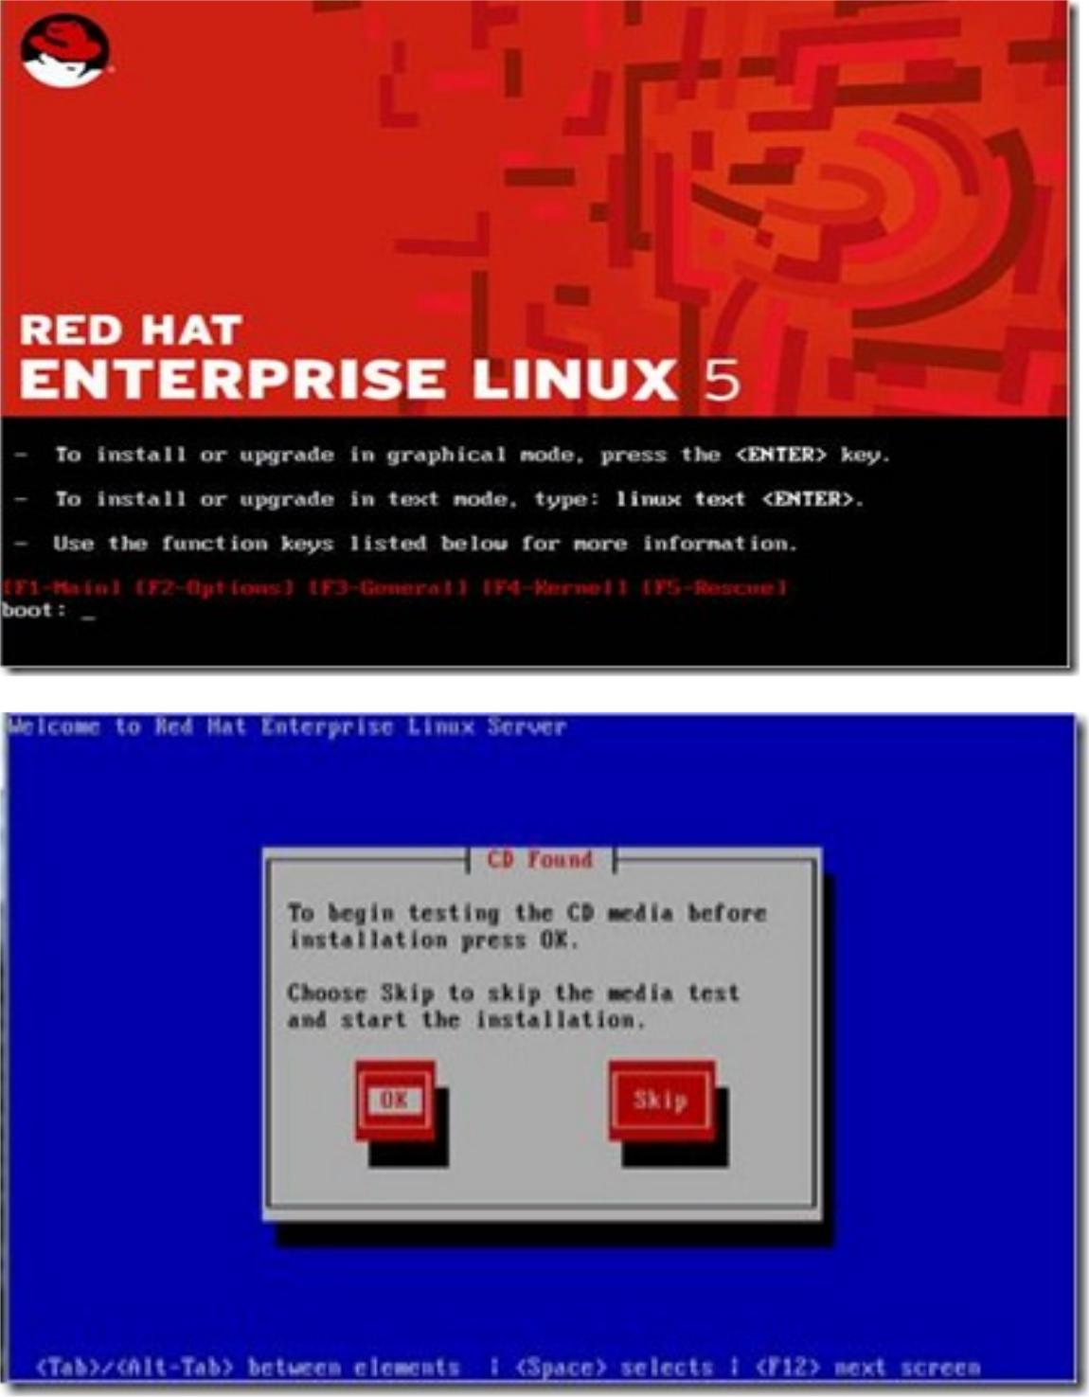

Installation of redhat in VMWare

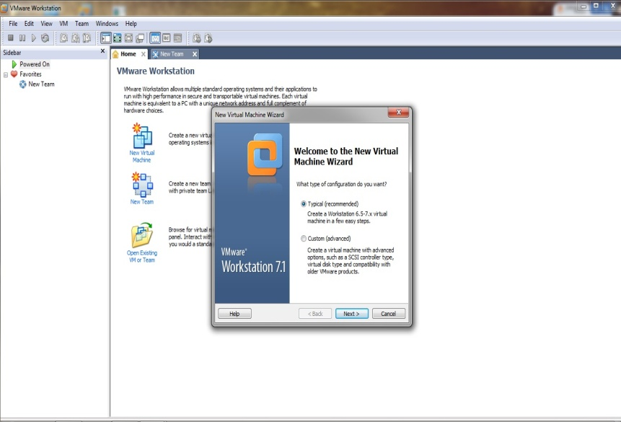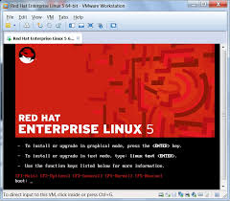

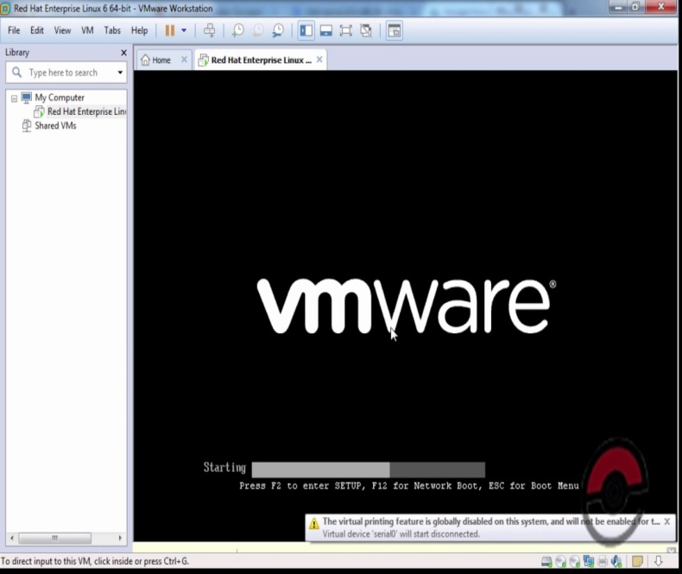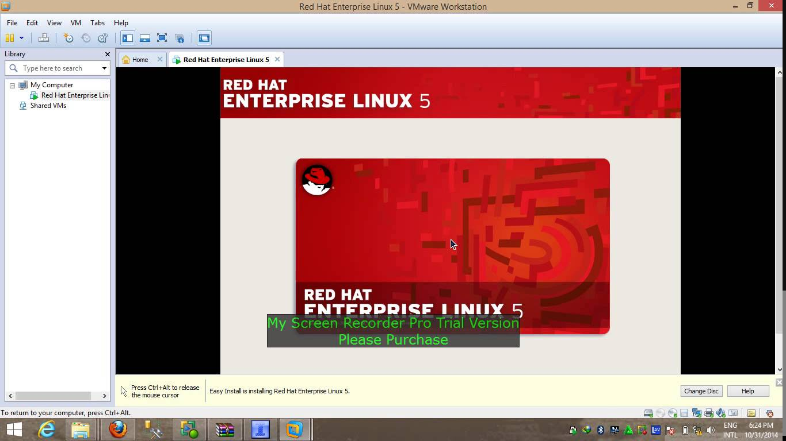

**RESULT:**

Thus the installation of redhatlinux has been successfully executed.

**Ex no:7a) Creating a user in Linux server and assigning rights**

**Aim:**

**To** Create a user in Linux server and assign rights.

**Hardware Requirements:**

HP system with intel core i3 cpu.

**Software Requirements:**

Redhatlinux standard edition

**Procedure:**

**Graphical Mode:**

* Create a new user.
* Select system->Administration ->user & group.
* To add new user select the user option in the user & group dialogbox.
* New user dialogbox appear till the appropriate option and click OK.
* Thus new user has been created.

**Adding user to group:**

* To add a user to particular group, open user properties window by just double click on the particular user.
* User properties dialog box appear and select the group tab.
* Now a list of groups available in redhatlinux.
* In the list of groups, select the check box the user which one you want to add.

**Deleting user from group:**

* First select the user to be deleted and click the delete option.
* A confirming dialogbox will appear press yes.
* Thus the user will be deleted.

**TERMINAL MODE:**

To start a terminal window session (*Applications -> Accessories ->Terminal*) and enter a command similar to the following:

#su

#useradd ram

#passwd ram

* To create a user in your directory,

# useradd –d /data/ram ram

* A user account may also be deleted from command-line using the *userdel* utility:

# userdel ram

**Linux user rights**

There are two types of user rights (traditional):

* File level user rights or permissions granted using chmod and chown command

If you type the following command:

$ ls -l

-rw-r--r-- 1 vivekwebusers 14814 2006-07-26 13:25 working-nixcraft.txt

Look at 3rd, 4th and last columns.

* vivek is username or the owner of the file (userid)
* webusers is group name, so all users in webusers can access file working-nixcraft.txt
* working-nixcraft.txt is the file name.

**change file owner and group**

Consider following example:

$ ls -l foo.txt

Output:

-rw-r--r-- 1 vivekwebgroups 8 2006-08-08 17:57 foo.txt

Change files ownership to tony user:

* chown tony foo.txt

# ls -l foo.txt

Output:

-rw-r--r-- 1 tony webgroups 8 2006-08-08 17:57 foo.txt

**Linux has three user classes as follows:**

* User (u): The owner of file
* Group (g): Other user who are in group (to access files)
* Other (o): Everyone else

**chmod command**

To setup file permission use chmod command:

chmod {mode} {file-name}

To setup file permission 761 use chmod command as follows:

# chmod 761 file

To setup a file readable/executable by everyone and writable by the owner only:

# chmod 755 file

Ex no 1:

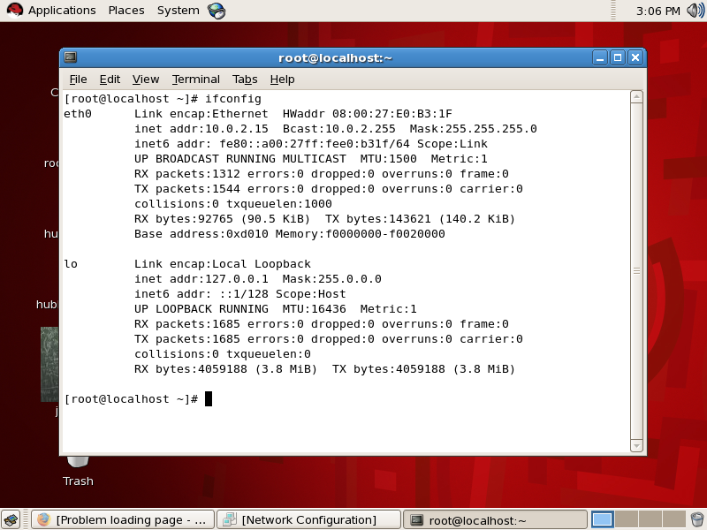

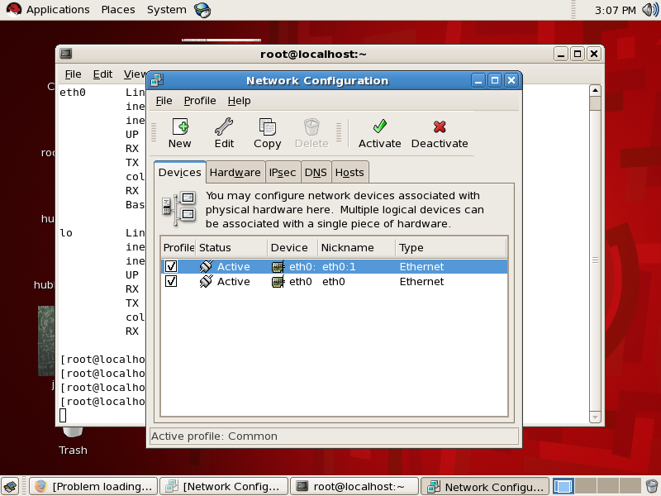

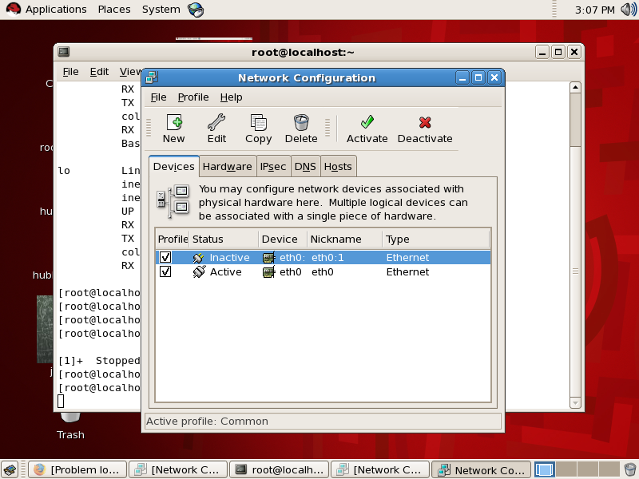

configuration

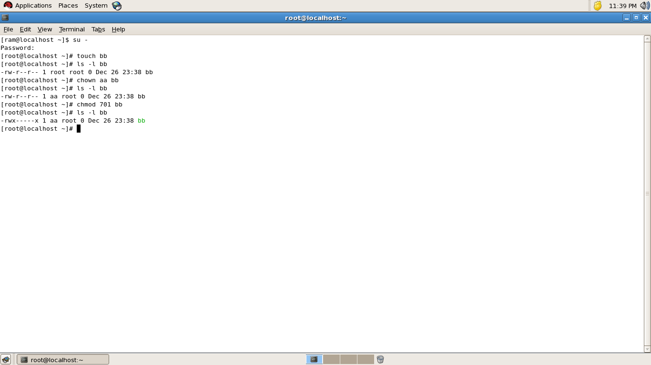

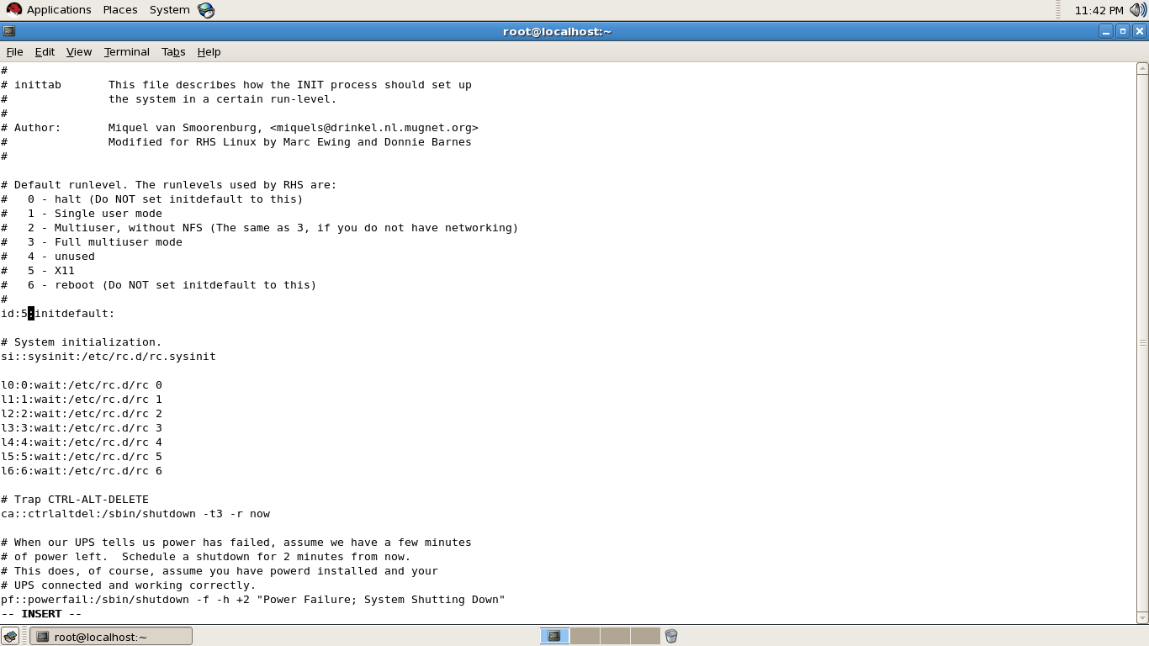

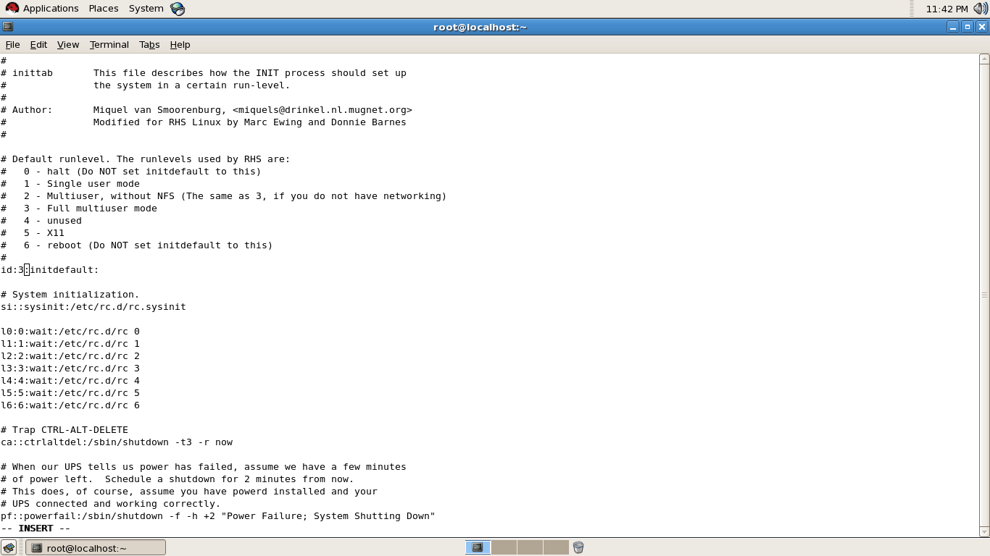

Troubleshooting:

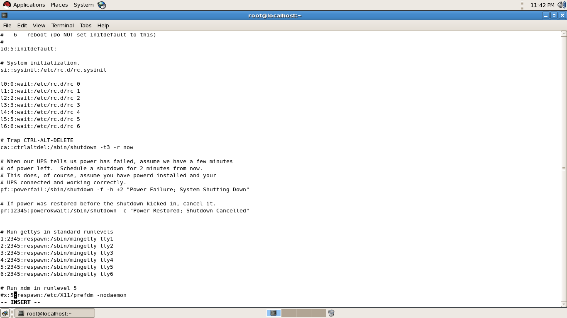

configuration



Troubleshooting



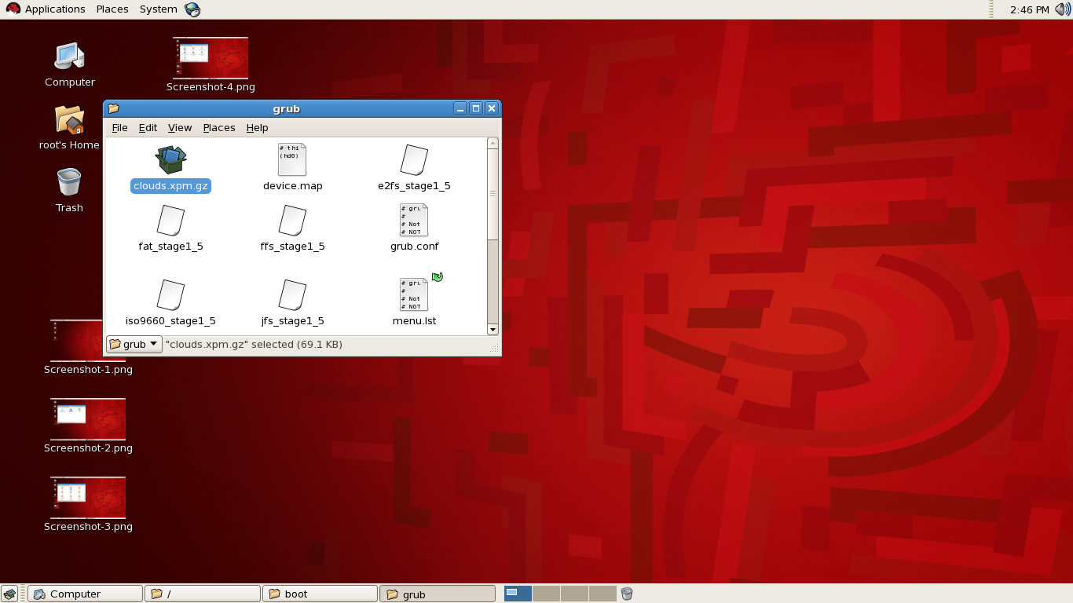

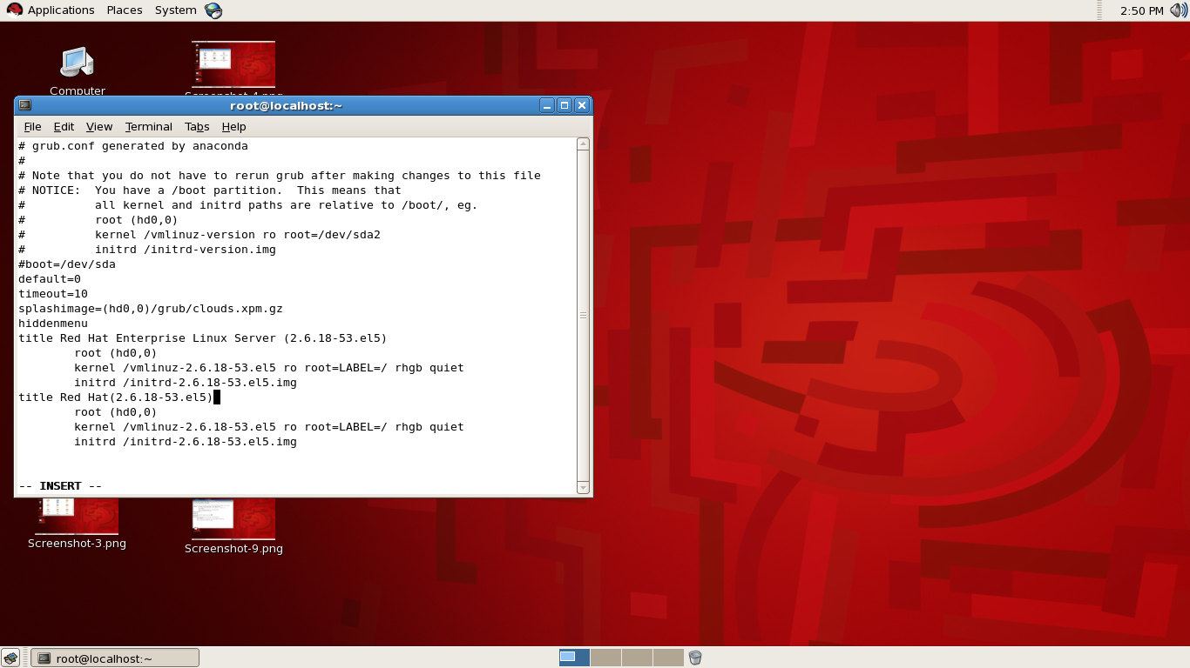

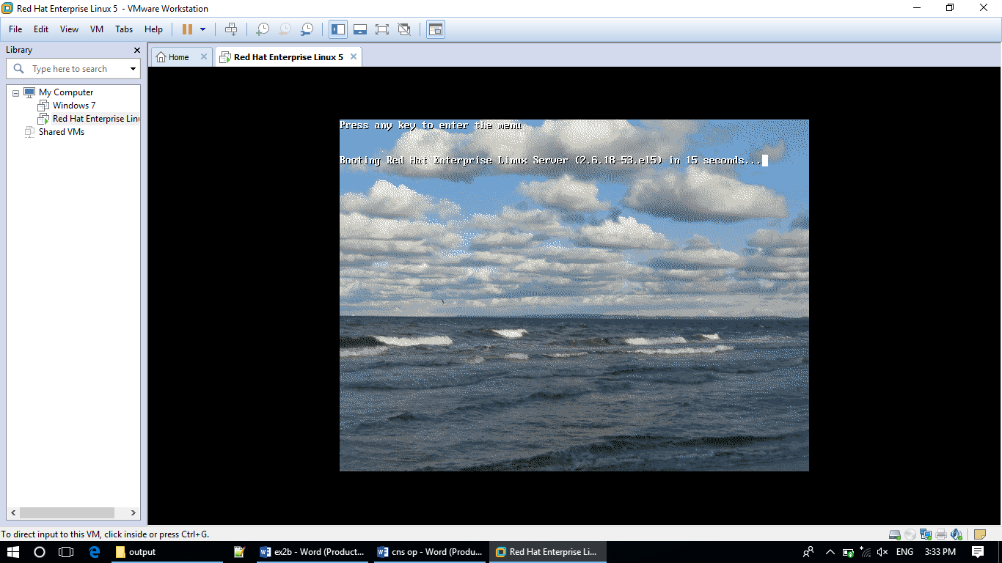

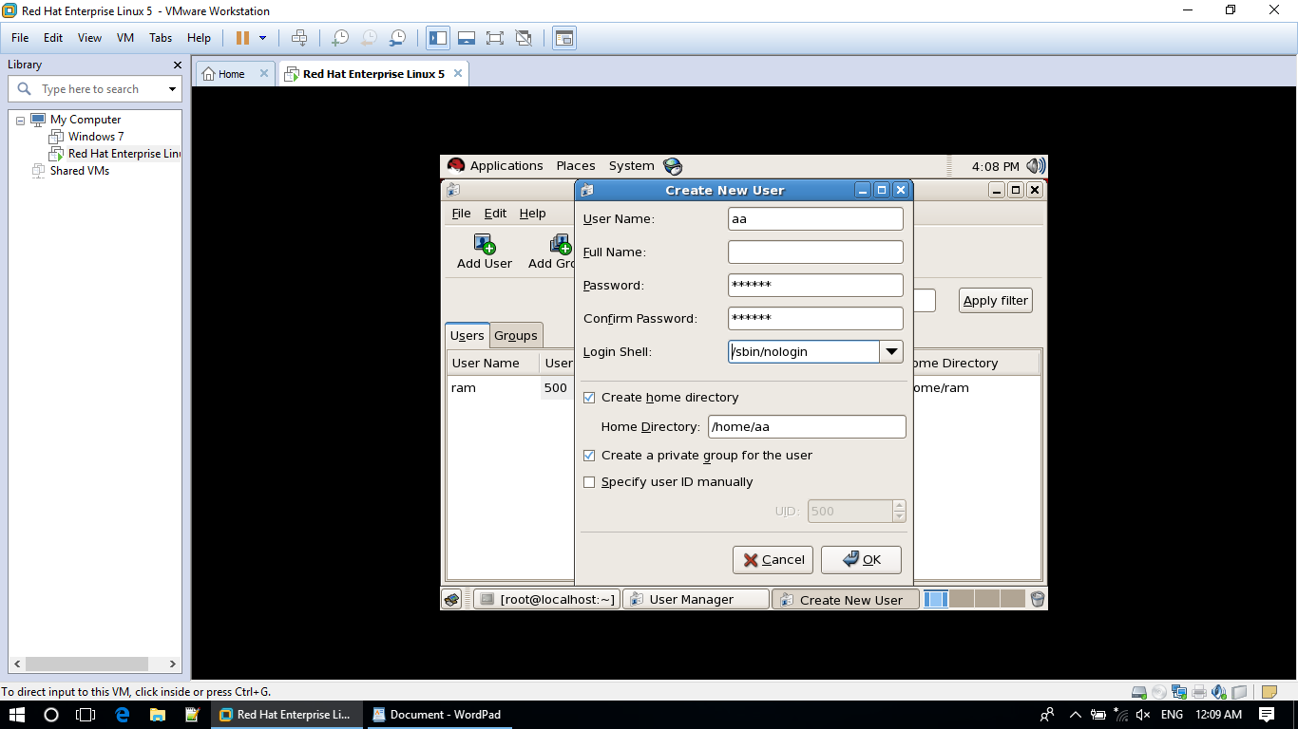

**Result:**

Thus the new user is created and permission was assigned successfully.

**Ex.No.7b)** **Configuring and Troubleshooting of /etc/inittab**

**Aim**

To Configuring and Troubleshooting of /etc/inittab.

**Hardware Requirement:**

HP system with intel core i3 cpu.

**Software Requirement:**

Redhatlinux standard edition

**Procedure:**

* **We can configure the following line in /etc/iniitab.**

The four fields per entry in *inittab* file.

***Syntax of that line*** ***:*** ***id*:*rstate*:*action*:*process***

* ***id***

This is up to four characters used to uniquely identify an entry.

* ***rstate***

This defines the *run-level* in which this entry is to be processed. The run-level 0,1,6 are reserved 0-half,1-single user mode,2- multi used,3-full multiuser mode,4-unused,5-X11,6-reboot.For example, **init** processes the entries which have a **2** (or no specified run-level) in this field when the system goes to run-level **2**,

* ***action***

Key words in this field tell **init** how to treat the process specified in the ***process*** field. A**init**recognizes the following actions boot, bootwait, initdefault, off, once, ondemand, powerfail, powerwait.

* ***Process***

This is a command to be executed by **sh**. The entire ***process*** field is passed to a forked **sh** to be run by **init**. For this reason, any legal **sh** syntax can appear in the ***process*** field. Comments can be inserted with the ; #***comment*** syntax.

**Example :**

id:5:initdefault:

**Troubleshooting of /etc/inittab:**

1. Login as root.
2. Open the terminal and type vi /etc/inittab window open and scroll down you can see the following line:  **id:5:initdefault:**
3. We can change id:5 as 3 then restart your computer after booting we can see the linux in command prompt.
4. Login as a root and change id as 5.
5. Now we get back our Linux is graphical mode.
6. if graphical mode does not work, go and check is there any error in the following line **x:5:respawn:/etc/X11/prefdm –nodaemon**

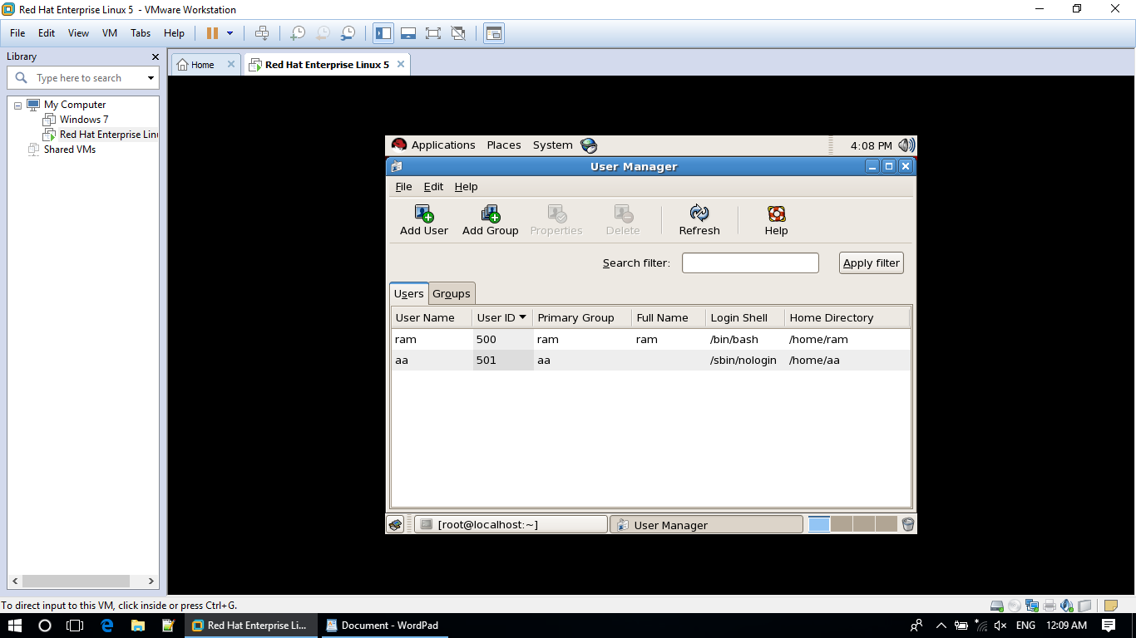

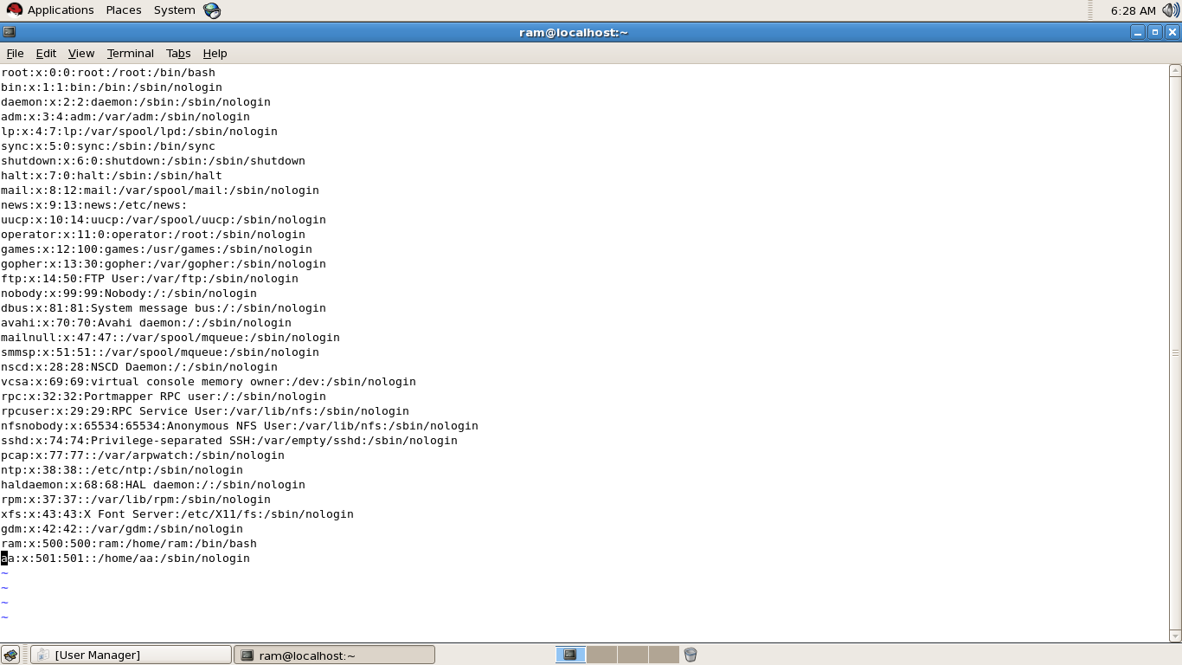

**Result:**

Thus the /etc/inittab file is configured and trouble shooted successfully.

**Ex.No.8a)Configuration and Troubleshooting of /etc/grub.conf**

**Aim:**

To configure and troubleshooting /etc/grub.conf inRedhatlinux server.

**Hardware Requirement:**

HP system with intel core i3 cpu.

**Software Requirement:**

Redhatlinux standard edition

**Procedure:**

**GRUB:**

GRUB(Grand Unified Boot Loader) is a program that install a boot loader to the MBR(Master Boot Record) which exists at the beginning section at a disk it allows you to place specific instruction in the MBR that loads a GRUB menu of command environment permitting you to start the operating system of your kernel only they boot.

**The *grub.conf* configuration file is explained in detail below.**

* The ***default=0*** directive points to the first stands,which is the default Operating System to boot.
* The ***timeout=5*** directive specifies the time, in seconds, for GRUB to automatically boots the default operating system.
* The ***splashimage*** directive locates the graphical GRUB screen.
* The ***hiddenmenu*** directive means that the GRUB options are hidden.
* A stands begins with a title, (the text to be displayed in boot menu for selecting the Operating System) and the next three lines specify the location of the /boot directory, the kernel, and the initial RAM disk
* ***root (hd0,0)*** - Specifies the boot directory is in first hard disk, first Partition.
* ***kernel /vmlinuz-2.6.18-8.el5 ro root=LABEL=/ rhgb quiet*** - Specifies the kernel location which isinside the /boot folder.
* ***initrd /initrd-2.6.18-8.el5.img*** - Initial RAM disk.

**Configuration of /etc/grub.conf file**

* Login as a root
* Open the file /etc/grub.conf
* Configure the timeout as 10 and adding a title.

**Troubleshooting of /etc/grub.conf file**

1. If background image does not work , check splashimage line whether it is correct image or not.







configuration







Troubleshooting:





Troubleshooting











**Result**

Thus the configuration and troubleshooting of /etc/grub.conf file has been performed.

**Ex.No.8b Configuration and Troubleshootingof /etc/passwd**

**Aim**

To configure and troubleshoot /etc/passwd file.

**Hardware Requirement:**

HP system with intel core i3 cpu.

**Software Requirement:**

Redhatlinux standard edition

**Procedure**

The /etc/passwd file stores essential information, which is required during login i.e. user account information. /etc/passwd is a text file, that contains a list of the system's accounts like user ID, group ID, home directory, shell, permissions etc.

**Understanding fields in /etc/passwd**

The /etc/passwd contains one entry per line for each user (or user account) of the system. All fields are separated by a colon (:) symbol. Total seven fields as follows.

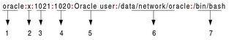

**/etc/passwd file format**

1. **Username**: It is used when user logs in. It should be between 1 and 32 characters in length.
2. **Password**: An x character indicates that encrypted password is stored in /etc/shadow file.
3. **User ID (UID)**: Each user must be assigned a user ID (UID). UID 0 (zero) is reserved for rootand UIDs 1-499 are reserved for other predefined accounts. Further UID 500-999 are reserved for regular users.
4. **Group ID (GID)**: The primary group ID (stored in /etc/group file)
5. **User ID Info**: The comment field. It allow you to add extra information about the users such asuser's full name, phone number etc. This field use by finger command.
6. **Home directory**: The absolute path to the directory the user will be in when they log in. If thisdirectory does not exists then users directory becomes /
7. **Command/shell**: The absolute path of a command or shell (/bin/bash). Typically, this is a shell.

**Configuring /etc/passwd file**

1. We can set user information such as fullname or phone in /etc/passwd file.

**Troubleshooting of /etc/passwd file**

1. If we could not login in linuxenvironment , first check whether shell entry is **/bin/bash** or **/sbin/nologin** for the corresponding user.



If the 7 th entry is /sbin/nologin , oracle user cannot login. So change it as /bin/bash then login to system.

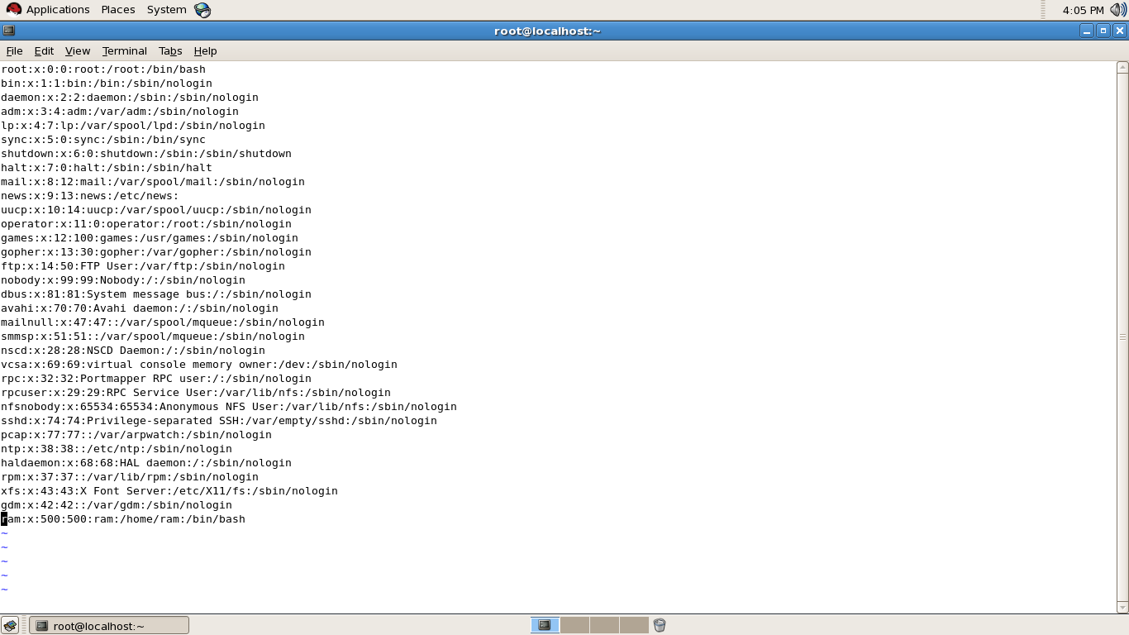





**Result**

Thus the configuration of troubleshooting of /etc/passwd file has been performed.

**EX NO: 9 TCP/IP Network Configuration**

**Aim**

To configure TCP /IP network in Linux environment.

**Hardware requirement :**

Intel core i3 or above

**Software Requirement :**

Redhat Linux el5 or above

**Procedure for configuration of TCP /IP**

**GRAPHICALMODE**

1. Select system -> administration -> network from linux Select new -> Device type -> Ethernet connection and click forward.
2. Select Ethernet card and click forward.
3. Click static ipaddress . Set ipaddress, subnet mask , default gateway and click forward and apply.
4. Click activate& yes.

**TEXTMODE**

* + 1. To configure the network , type as

**#system-config-network**

2. To check the configuration made , type as

**# ifconfig**

ifconfig displays the status of the currently active interfaces.

3.Type**#service network restart**to restart the network service.

* After restart or activation , check whether the network worked or not by

**# pingipaddress**

* If network problem , check whether network card enabled or not.

**#ifup eth0 - start network card**

**#ifdown eth0 – stop network card**

* The static host IP assignment is saved in **/etc/hosts**













Troubleshooting:



Ex no:2b

configuration



Troubleshooting

















**RESULT**

Thus the configuration of TCP /IP in linux environment has been worked out.

**Ex .10.** **SHARING OF DATA USING SAMBA SERVER**

**Aim:**

To install and configure Samba Server on ubuntu for file sharing.

**Hardware Requirements:**

Network cable with RJ45 connector

Intel core i3 cpu with WindowsXP.

Intel core i3 cpuwith UBUNTU Server.

**Procudure:**

1. Set server IP address as 192.168.1.122
2. Set client IP address as 192.168.1.123
3. Connect 2 system with networkcable.

**Important Files are**:

Smbd : Provides Smblofs service(File Sharing and printing) can also act as a Window Domain controller.

Hmbd: It allows the Samba Server to be seen by other Computer in the network.

**Graphical mode**:

1. Install samba server in ubuntusystem .

#sudo apt-get install samba*

1. Create a shared folder.

Home -> folder-> right click and select

Properties-> select local network share

* Select allow others to access
* Click create share and select add permissions tab.
* Create new file in the folder.

1. Go to terminal and type ifconfig to check ipaddress.
2. Create samba username

#sudouseradd –M –g sambashareaa

Here aa -username ,sambashare – groupname.

1. Set sambapassword to username

#sudosmbpasswd –aaa

1. Type exit to exit from ubuntu.
2. Go to windows system.
3. Type ipaddress of ubuntu system in run dialog box.

Ex. \\192.168.1.122

1. Now, double click the shared folder and give username

And password to access the file. We can also edit the file here

And we can check into ubuntu system.

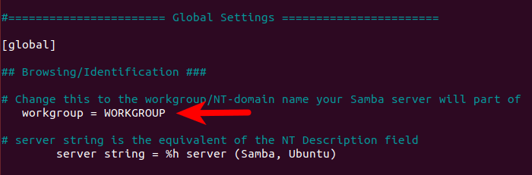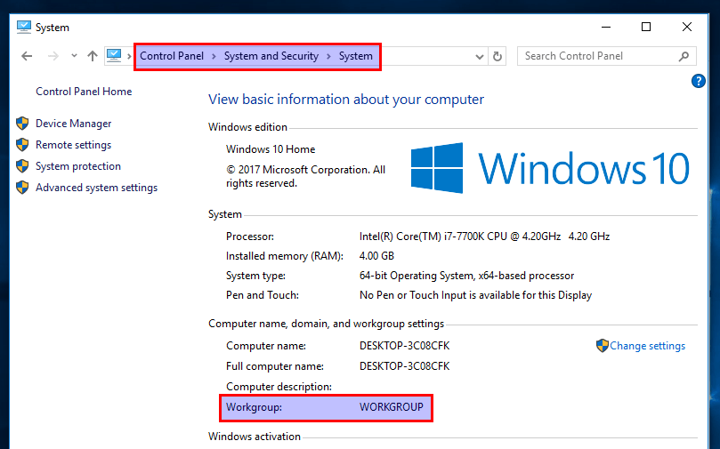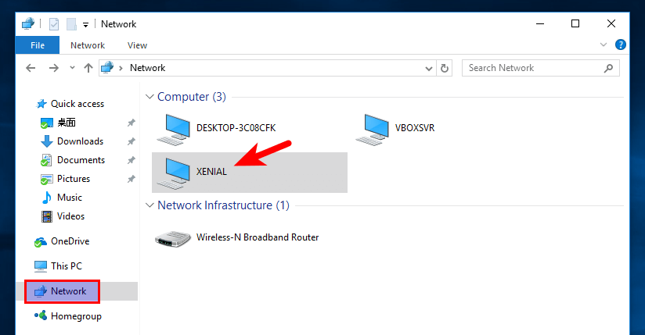

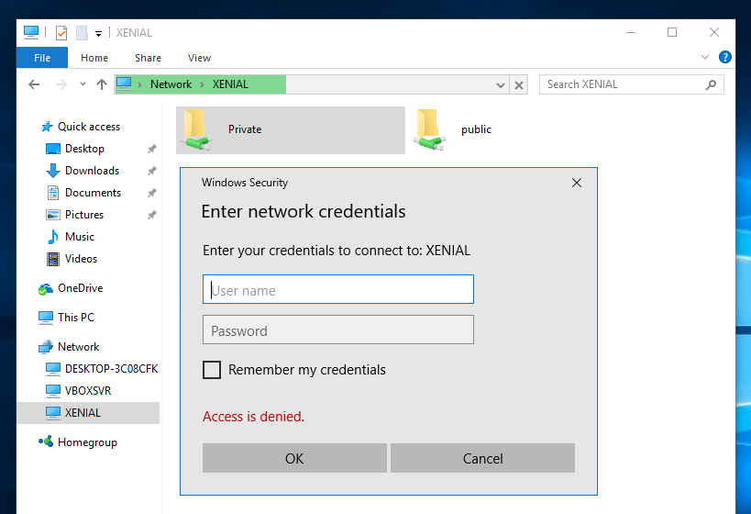

.

**Result:**

Thus the Sharing of file between Linux and Windows using Samba Server executed successfully.